Sharing and Strengthening our Practice: Northern Territory domestic, family and sexual violence conference 2024
  - Conference outcomes report

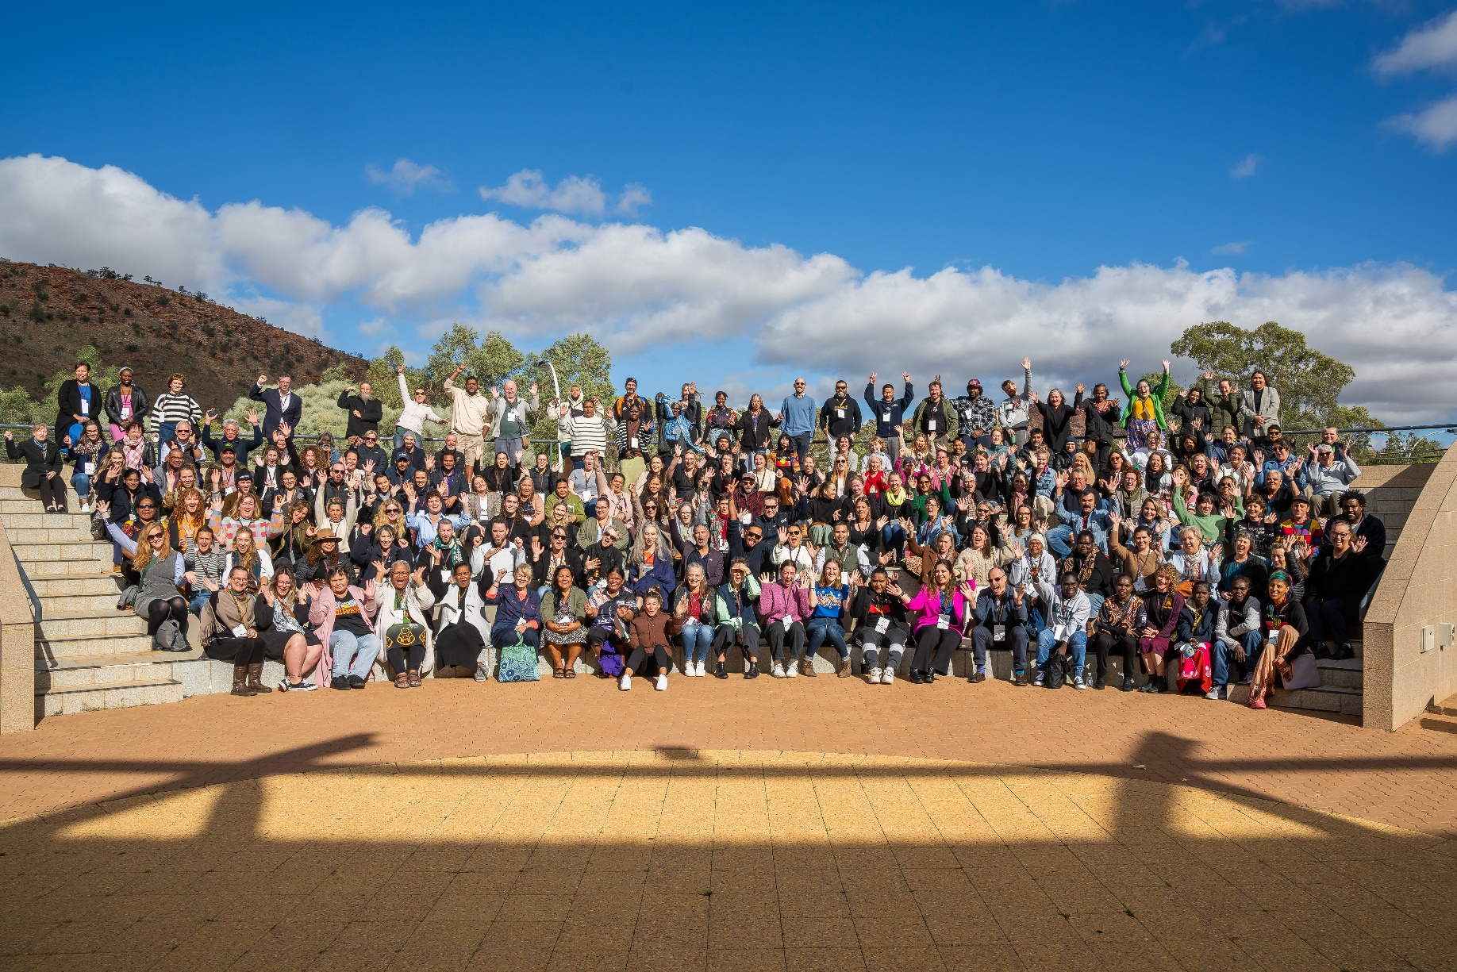

Contents
Acknowledgements 3
Aboriginal acknowledgement 3
Victim survivor acknowledgement 3
Acknowledgement of broader conference support 3
Executive Summary 4
Acknowledgement of living and lived experience of domestic, family and sexual violence, and homelessness 6
1. Background 7
Objectives 7
2. SSOP 2024 Overview 8
Conference themes and topics 8
Attendee Wellbeing 11
Exhibitors 11
Conference Session Graphic Illustrations 11
3. Demographics 12
Speaker demographics 13
Attending organisations 13
Support for sector attendance 15
4. Feedback from conference delegates 16
Areas for improvement and suggestions for future conferences 18
Opportunities for Improvement 18
Program structure 18
Themes, topics and speakers 19
Venue and logistics 19
5. Budget 20
6. Where to from here? 21
Appendixes 22
Conference Presentations and Topics 22
Session Graphic Illustrations 28

Cover image: Group photo of conference delegates

Acknowledgements

Aboriginal acknowledgement
Department of Children and Families respectfully acknowledges the First Nations people of this country and recognises their continuing connections to their lands, waters and communities. We pay our respects to the Arrernte people as the Traditional owners of the land in which the conference was held, and pay respect to their leaders past, present and emerging.

Victim survivor acknowledgement
We acknowledge the women and children who have suffered and died in the Northern Territory as a result of domestic, family and sexual violence. We are committed to honouring the lives of those killed, learning from these tragedies and translating those learnings into action so as to prevent future harm. We acknowledge the disproportionate impact of violence on women in the Northern Territory, particularly Aboriginal women. We acknowledge the courage and dignity of all those who stand against domestic, family and sexual violence, who take action to challenge the violence, and who hold people who use violence accountable.

Acknowledgement of broader conference support
We thank the conference committee representatives, our event organisers, Agentur, and staff at the conference venue, Alice Springs Convention Centre, who assisted in the planning and organisation of the event. We also extend a special acknowledgement to our Masters of Ceremonies, our keynote speakers, presenters and chairs who invaluably shared and imparted their time and wisdom at the conference. Photos in the conference report have been included with permission.
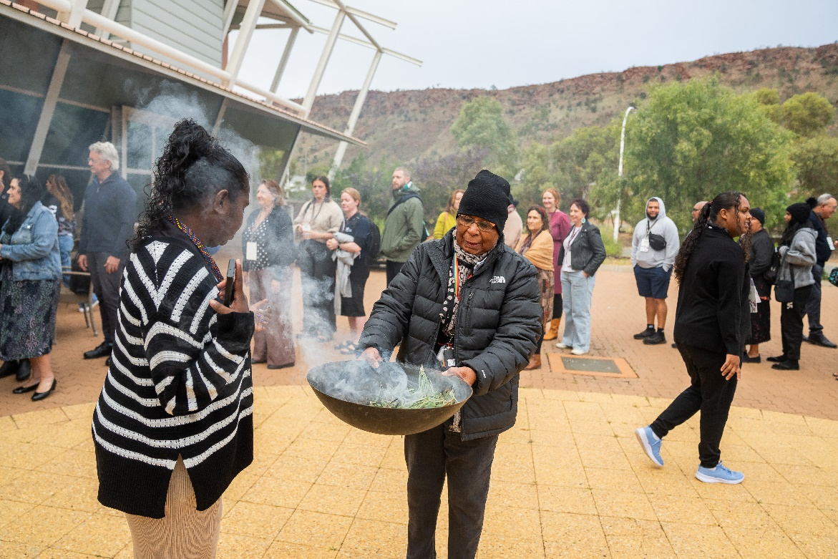
Image 1 Kumalie Kngwarraye performing smoking ceremony to open the conference.

Executive Summary
This report provides an overview of the Northern Territory’s Sharing and Strengthening our Practice domestic, family and sexual violence (DFSV) conference 2024 conference, and the ideas, discussions and feedback received from delegates and speakers.
SSOP 2024 was held on 5 and 6 June 2024, bringing together over 250 specialist DFSV prevention and response sector workers, supervisors, managers, and executives from both government non-government organisations across the Northern Territory.
The SSOP objectives are to:
- Facilitate a culturally safe and collaborative environment to encourage discussion and strengthen connections between DFSV prevention and response workers and managers and between the sector and government
- Provide a forum to celebrate, reflect and share information, ideas and concerns
- Build DFSV prevention and response workforce capability and resilience through learning from experienced sector representatives including keynote speakers and presenters.
Sharing and Strengthening our Practice (SSOP) 2024 provided the opportunity for workers to share their experiences and knowledge, and learn from guest speakers, about the latest issues, trends and responses in the DFSV services sector. There was a broad range of topics covered that focused on promising practice, including bi-cultural ways of working, bringing men to the table to address DFSV and valuing the victim survivor voice.
- “I enjoyed learning about programs across the Territory that are doing really interesting work to bring an end to domestic family sexual violence.”
- “I believe there is a greater awareness of what the sector is achieving. I enjoyed the value in challenging the perception.”
- “The fact that the conference was led by Aboriginal voices, knowledge and strength was essential to the relevance and success of the conference.”
- “I enjoyed learning from other services and learning how other services work. I enjoyed hearing from victim survivors’ voices. I thought networking was easy. The conference was a very relaxed and human experience.”
- “I enjoyed listening to shared challenges and opportunities - it brings hope.”
- “The conference was aspirational and gave a sense of hope.”’

SSOP 2024 included keynote presentations, panel discussions and workshops, providing an opportunity to bring together the sector and share challenges and opportunities, 5 years after the inaugural conference in 2019. Delegates who attended the conference noted the strength and relevance of the topic added to the success of the conference, and felt the conference was aspirational, giving delegates a sense of hope.
Of the 250 delegates:
- one quarter were born in a country outside of Australia
- almost a third identified as Aboriginal and/or Torres Strait Islander
- a third were local to Alice Springs
- over half have worked in DFSV related fields for more than 5 years.
Thirty-two (32) delegates were supported with travel and accommodation expenses, enabling attendance from outside Alice Springs, regional and remote areas, including Galiwin’ku, Ramingining, Nhulunbuy, Wadeye and Lajamanu.
A diverse mix of speakers were included on the program, with a strong representation from NT based practitioners from non-government organisations (NGOs) or Aboriginal Community Controlled Organisations (ACCOs). One third of speakers identified as Aboriginal and/or Torres Strait Islander, and almost one quarter were born outside of Australia. Almost one in five speakers identified as male, representing an increase in speaker diversity on the 2019 conference.
The next SSOP conference will be held in 2026.
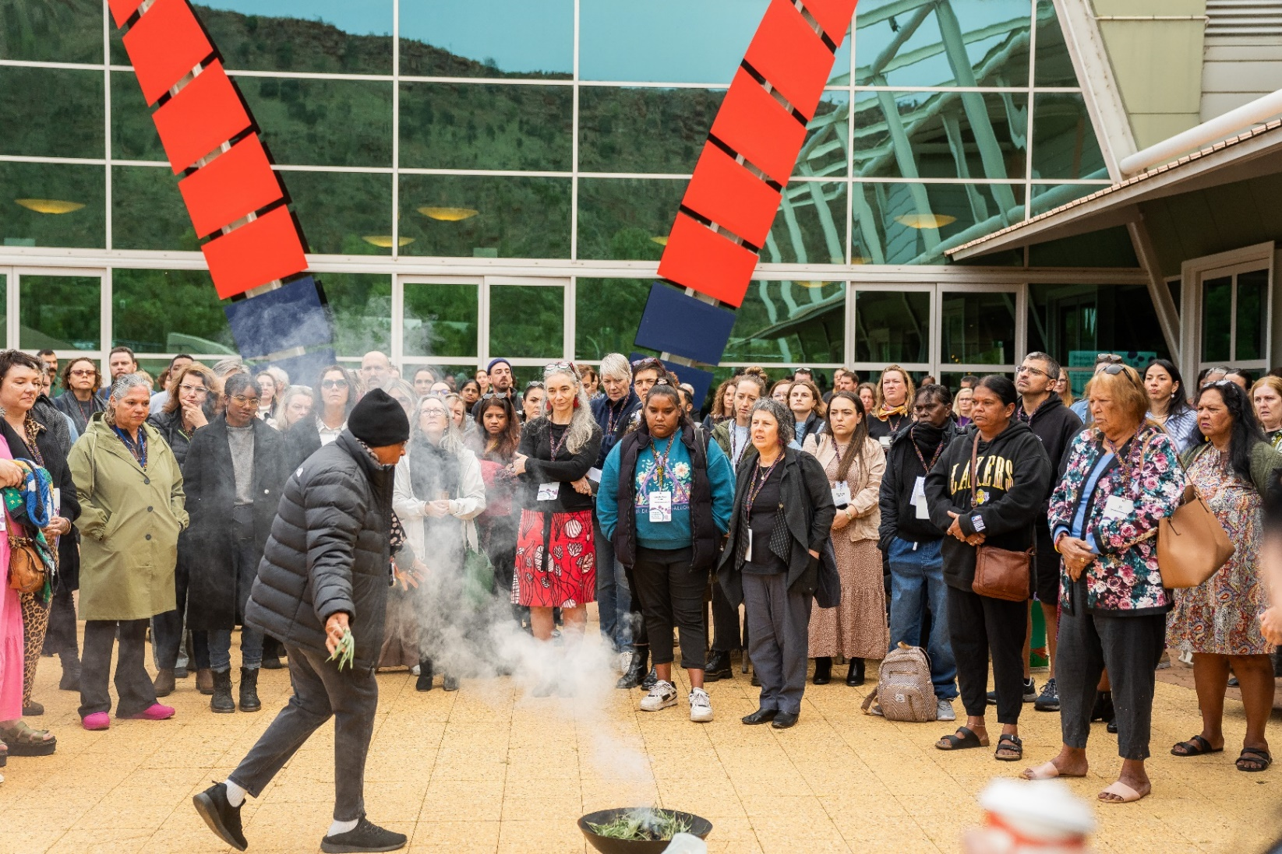
Image 2 Kumalie Kngwarraye performing smoking ceremony.

Acknowledgement of living and lived experience of domestic, family and sexual violence, and homelessness
We acknowledge the individual and collective expertise of those with a living or lived experience of domestic, family and sexual violence, and homelessness.
We stand together as proud survivors with diverse experiences that reflect the resilience, compassion, creativity and bravery of other women and children who have experienced domestic, family and sexual violence and homelessness.
We understand the complexity of each survivor’s journey and the value of exchanging the knowledge from our experiences to lead and advocate for meaningful change.
Together we can be the most powerful agents for preventing and responding to family, domestic and sexual violence, and homelessness. Because personal is political and our personal commitment is to end violence, by ending our silence.
This acknowledgement of living and lived experience was created by the YWCA Amplifying Voices 2024 Leadership and Advocacy Group, some of whom presented at and participated in SSOP 2024. This acknowledgement aims to generate space for the voices of people with lived experience to be recognised across places of influence.
Intentions set by Amplifying Voices for using this acknowledgement are to:
- promote the strengths and value of people with living and lived experience of DFSV and homelessness.
- build understanding about the collective expertise of people with lived experience.
- challenge the deficit perspective held by others about victim/survivors, which is disempowering and obstructive to their healing journey.
Amplifying Voices have provided permission to use the acknowledgement.

Background
The Northern Territory’s DFSV Reduction Framework 2018-2028 identifies that an effective DFSV sector requires quality staff and practices embedded in professional standards, with knowledge of the local and specific socio-cultural contexts of their clients as well as the networks of families and communities they work with. Collaboration and coordination with other services and agencies is essential for both effective client outcomes and accountabilities.
The Northern Territory DFSV Workforce and Sector Development Plan outlines 3 focus areas for the DFSV workforce.
- Workers have the right skills and support to provide effective services.
- Specialist services are accountable, sustainable, responsive to emerging needs and support the health and wellbeing of their workers.
- The sector is strong, sustainable, collaborative and integrated, so that clients experience a joined-up system.
A key initiative and ongoing action under Action Plan 1: Changing Attitudes, Intervening Earlier and Responding Better (2018-2021), was to invest in the sector to improve practice through the establishment of a biennial DFSV conference for frontline workers and practitioners (Action 5.5a). The conference is also an action under the DFSV Workforce and Sector Development Plan, and the commitment continues under Action Plan 2.
The first SSOP conference was held in Darwin in 2019.
This is the second time the SSOP conference has been held, due to COVID-19 and resource limitations that meant it was not possible to hold the conference in 2021-22 or 2022-23.

Objectives
The conference was organised by the Domestic, Family, Sexual Violence Reduction (DFSVR) Division of the Department of Children and Families, with support from conference organisers Agentur.
The objectives of SSOP 2024 were to:
- facilitate a culturally safe and collaborative environment to encourage discussion and strengthen connections between DFSV prevention and response workers and managers and between the sector and government
- provide a forum to celebrate, reflect and share information, ideas and concerns
- build DFSV prevention and response workforce capability and resilience through learning from experienced sector representatives including keynote speakers and presenters.
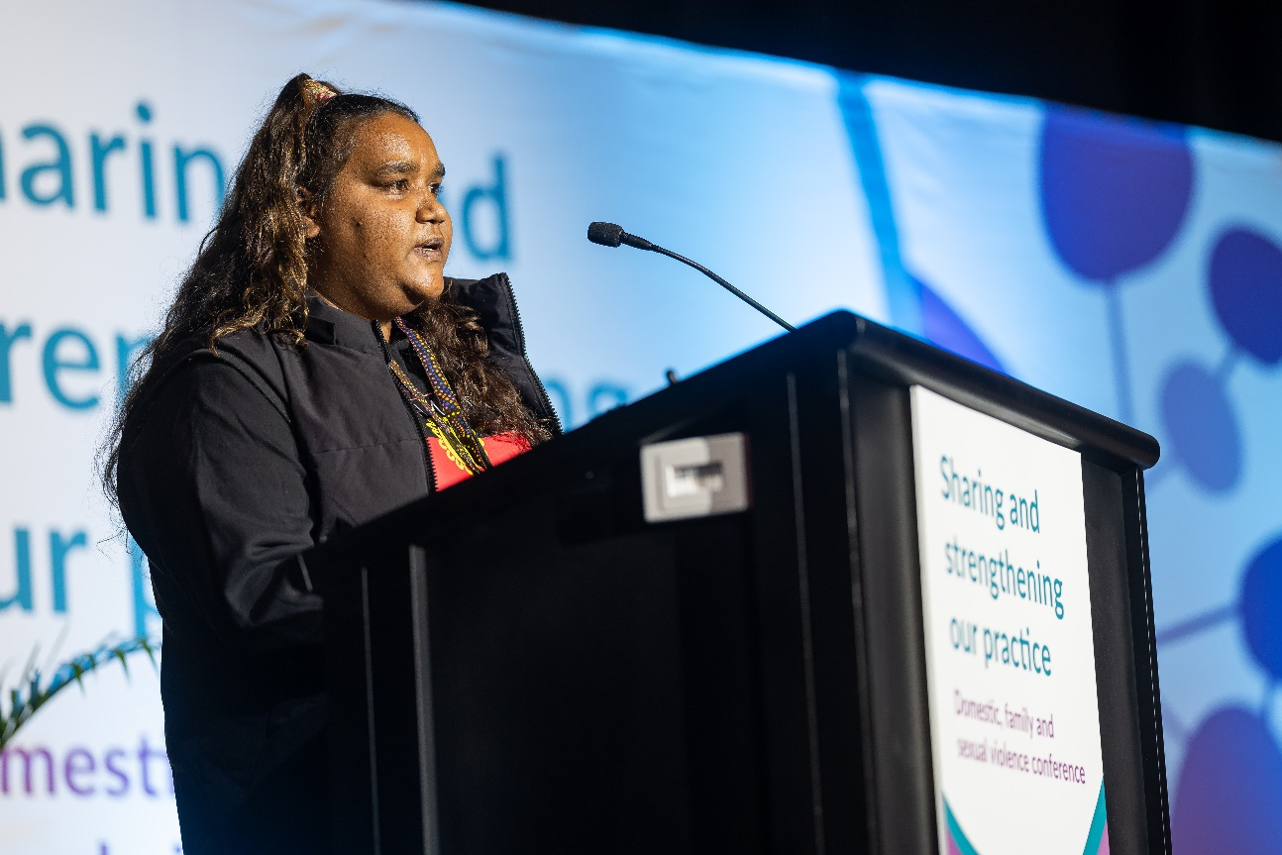
Image 3 Keynote speaker, Connie Shaw, Tangentyere Council Aboriginal Corporation

SSOP 2024 Overview

Conference themes and topics
There were a broad range of topics presented over the two days at SSOP 2024. The topics were carefully considered in bringing the sector together to share new ideas and learnings, as well as discuss how far the Northern Territory has come and how far we have to go, together.
Delegates at the 2019 conference provided feedback on how to improve future conferences, including:
- more opportunities for panel discussions
- focus of keynotes to include a greater focus on the context of DFSV in the NT
- less theory and a greater focus on practice
- focus on the context of DFSV in the NT
- greater representation, participation and presentation at the conference from:
  - Aboriginal speakers
  - men and male speakers, programs working with men who use violence
  - people and/or workers with lived experience of DFSV
  - people who identify as LGBTQIA+
  - people with disability
  - people from culturally and linguistically diverse backgrounds
  - people from migrant and refugee backgrounds.
As a result of this feedback in 2019, SSOP 2024 aimed to increase the focus on NT practice, with less theoretical practice, providing delegates access to the unique DFSV practice landscape of the NT, including showcasing lived experience, DFSV practice relating to men and men’s behaviour change programs.
Consultation on the SSOP 2024 program topics was undertaken with members of the DFSV Advisory Forum (formerly known as Cross Agency Working Group). A draft program was developed and consulted on further with key representatives nominated by the DFSV Advisory Forum. The program was finalised based on speaker availability and interest in participating.
The conference was opened by the then Minister for the Prevention of Domestic, Family and Sexual Violence. Three keynote presentations were provided, all by Aboriginal women, sharing their experiences and learnings to support DFSV practice in the Northern Territory. Keynote speakers included:
- Connie Shaw, Coordinator Future Yayes and member Women’s Family Safety Group, Tangentyere Council
- Aunty Muriel Bamblett, Co-Chair Aboriginal and Torres Strait Islander Family Safety Plan and Chair of Secretariat National Aboriginal Islander Child Care
- Phynea Clarke, CEO of Central Australian Aboriginal Family Legal Unit.
The conference program was structured to provide a mix of presentations in an auditorium, and small group workshops in breakout rooms. The auditorium included panel discussions featuring perspectives of workers with a breadth of experience on key topics, and presentations on key projects. Small group workshops were delivered by experts on a program, issue or research, with some offering skill building activities and others providing information.
Topics and speakers are listed below, with details on panels, presentations, and workshops in the Appendix.
Panel, Presentation and Workshop Topics | Speakers
Working Two Ways, The Value of Aboriginal Knowledge and Bicultural Employment Models in DFV Prevention and Response | Penny Drysdale (Facilitator), Rachel Neary, Miriam Bevis, Rhoda Dhurrkay, Melody Dale and Sylvia Ŋulpinditj.
Partnering to Strengthen Responses to DFSV | Seranie Gamble (Facilitator), Julianna Marshall, Jieun Chun, Maree Corbo and Fiona Hussin.
Bringing Men to the Table to Address DFSV | Kim Mulholland (Facilitator), Anthony Ah Mat, Kudzai Mutsunge, Rob Cross and Michael Liddle.
Lived Experience – Valuing the Victim Survivor Voice | Ameina Brunker (Facilitator), Stephanie Metry, Shalini Hemraz, Gemma White and Shirleen Campbell.
Complexities of Behaviour Change | Desmond Campbel (Facilitator), Michael Brandenburg, Luke Addinsall and Celeste Brand.
Prevention in Action: Primary Prevention as Everyone’s Responsibility | Claire Pirrett (Facilitator), Emma Gerard, Kelly McCarthy, Amanda Merrett.
Men Standing up Against Violence | Facilitated by Kim Mulholland and Desmond Campbell
Responding to Misidentification | Amanda Lambden, Tania Collins and Julianna Marshall
Sexual Harassment in the Workplace | Lisa Dietrich and Julia Parkins
DFV Death Review Workshop | Penny Drysdale
Supporting Staff Experiencing and Using DFSV | Emily Kilpatrick and Lisa Dietrich.
Five Steps to Supporting Clients on Visas Experiencing DFSV | Alyce Boemia and Jorja Costello
Listening to the Voices of Aboriginal and Torres Strait Islander Women About Traumatic Brain Injury from Family Violence | Elaine Wills and Michelle Fitts
Safe and Together Domestic Violence Informed Practice, First Nations Context | Jo Greene and Denella Detourbet
Creating Healing Connection in Emergency Department Care | Dr Lucy Owen
Project Showcase (Presentations) | Girls Can, Boys Can; uHaven; Channels of Hope for Gender; Dhatam Primary Prevention Program; Safer Communities for Children; School Lawyer Project; Nissa; Amplifying Voices; All Good Project; NO MORE campaign; Future Yayes Group.
A Systemic DFV Death Review Process for the Northern Territory (Presentation) | Penny Drysdale
- “I enjoyed learning about programs across the Territory that are doing really interesting work to bring an end to domestic family sexual violence.”
- “I believe there is a greater awareness of what the sector is achieving. I enjoyed the value in challenging the perception.”
- “The fact that the conference was led by Aboriginal voices, knowledge and strength was essential to the relevance and success of the conference.”
- “I enjoyed learning from other services and learning how other services work. I enjoyed hearing from victim survivors’ voices. I thought networking was easy. The conference was a very relaxed and human experience.”

Attendee Wellbeing
The Calm Room was provided across both days as a trauma-informed space that delegates could access at any time throughout the conference with dedicated counsellors available. The Calm Room had a space to speak to a mental health professional privately, soft lighting and music and structured and unstructured art therapy activities.

Exhibitors
The conference provided an opportunity for exhibitors to share information about key resources and programs available to support workforce and sector development in the NT. Nine (9) exhibitors attended, including:
- No More program, CatholicCare NT
- Gender and Disaster
- E Safety Commissioner
- NAPCAN, Safer Communities for Children and Love Bites
- Girls Can, Boys Can, Tangentyere Council
- Our Watch
- Relationships Australia NT
- Berry Street Money Minded
- Central Australian Women’s Legal Service (CAWLS)
- Central Australian Aboriginal Family Legal Unit (CAAFLU).

Conference Session Graphic Illustrations
Sarah Cook, Graphic Recorder was engaged to capture the panel discussions through live graphic illustrations, provided in the Appendix.

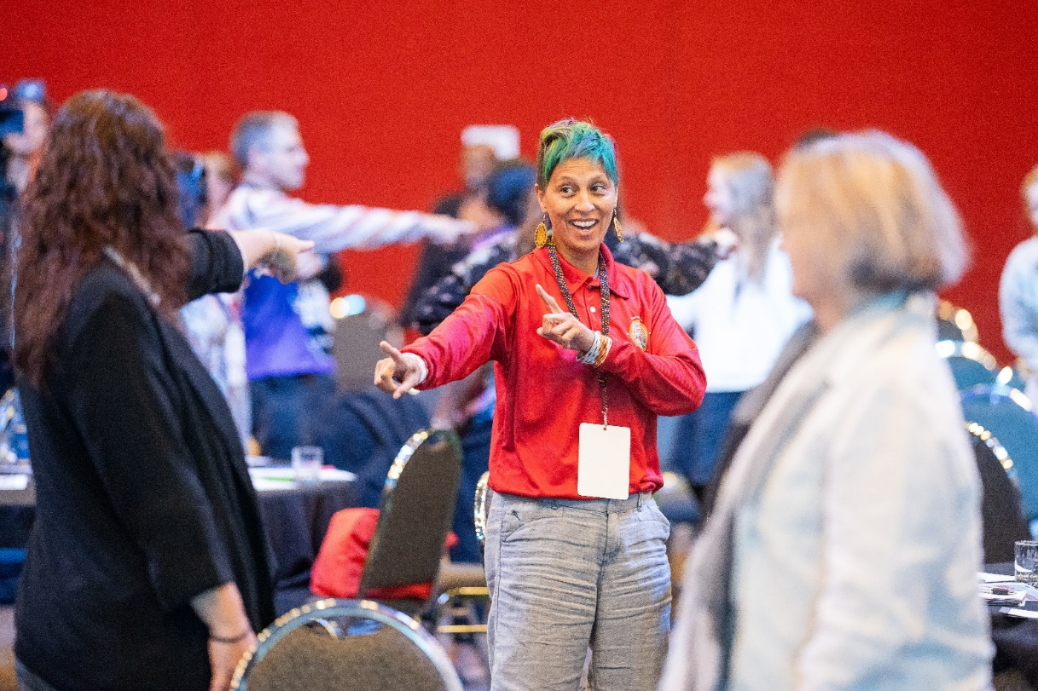
Image 4 Conference delegates during activity.

Demographics
Over 250 delegates from government, NGOs and ACCOs, who work in and with the DFSV sector across the Northern Territory, attended SSOP 2024 in Alice Springs. The conference had a 47% increase in attendance in comparison to the 2019 conference, which had 170 delegates attend.

Delegate demographics
Of the 232 delegates with available demographic data:
- 21% (51 people) were born in a country outside of Australia
- 93% (216 people) live in the Northern Territory
- 27% (68 people) identified as Aboriginal and/or Torres Strait Islander
- 64% (149 people) have lived in the Northern Territory for more than 5 years
- 51% (119 people) have worked in DFSV related fields for more than 5 years
- 33% (77 people) were local to Alice Springs, 41% (103 people) from Greater Darwin, and 22% (52 people) travelled from other areas.

Speaker demographics
Speakers, including panellists, presenters and workshop hosts included a diverse level of experience and expertise, including:
- 35% identified as Aboriginal or Torres Strait Islander
- 88% lived in the Northern Territory
- 71% worked for Non-Government Organisations or Aboriginal Community Controlled Organisations
- 17% were born outside of Australia
- 83% identified as woman
- 15% identified as man.

Attending organisations
Delegates represented a diverse spread across the DFSV sector, including 23% (53 people) from ACCOs, 39% (92 people) from NGOs, and 28% (66 people) from Government agencies. Data was not provided for 21 attendees.

Government | Non-Government Organisations | Aboriginal Community Controlled Organisations
Alice Springs Correctional Facility | CatholicCare NT | AMSANT
Alice Springs Town Council | Central Australian Women’s Legal Service (CAWLS) | Anyinginyi Health Aboriginal Corporation
Barkly Regional Council | CDU Tafe | Aboriginal Peak Organisations NT
Department of Attorney General and Justice | Community Housing Central Australia (CHCA) | Aboriginal Resource Development Services Aboriginal Corporation
Department of Territory Families, Housing and Communities | Darwin Community Legal Service | Central Australian Aboriginal Congress (CAAC)
ESafety Commission | Dawn House | Central Australian Aboriginal Family Legal unit (CAAFLU)
Northern Territory Police | Gender and Disaster Australia | Darwin Aboriginal & Torres Strait Islander Women’s Shelter
Northern Territory Department of Health | Katherine’s Women’s Crisis Centre Inc | Galiwinku Womens Space Aboriginal Corporation
 | Menzies School of Health Research | Katherine West Health Board
 | Miyalk Domestic and Family Violence Shelter | North Australian Aboriginal Justice Agency (NAAJA)
 | MusicNT | Miwatj Aboriginal health Corporation
 | National Association for Prevention of Child Abuse and Neglect (NAPCAN) | North Australian Aboriginal Family Legal Service
 | NT Council of Social Services (NTCOSS) | NPY Women’s Council
 | Northern Territory Legal Aid | Tangentyere Council
 | Northern Territory Primary Health Network (NT PHN) | Urapuntja Health Services
 | One Tree Community Services | Wurli Wurlinjang Health Service
 | Our Watch | Yalu Aboriginal Corporation
 | Relationships Australia NT
 | The Salvation Army
 | Top End Women’s Legal Service (TEWLS)
 | United Muslims Northern Territory (UMNT)
 | Uniting Vic Tas
 | University of Sydney
 | Western Sydney University
 | Women’s Safety Service of Central Australia (WoSSCA)
 | World Vision Australia
 | YWCA Australia

Support for sector attendance
To encourage participation and ensure a diverse and inclusive conference delegation from across the Northern Territory, the DFSVR Reduction Division reimbursed travel for anyone attending the conference who was based 100km outside of Alice Springs CBD, or any Northern Territory resident who worked at a non-government organisation. Travel across the Northern Territory can be expensive given the remoteness and accessibility of the regions.
The purpose of subsidising travel for delegates was to ensure that delegates had the opportunity and financial means to get there, despite the distance, or their organisation’s financial capacity.
A total of 32 delegates (13%) received financial assistance to travel to the conference. Where required, accommodation was provided during transit stopovers and one day before or after the conference to enable remote multi-stop trips. Eight delegates sought fuel cost reimbursement for travelling by car, with the majority (n=24) travelling by plane.
Through the support of travel subsidies, there were delegates who attended from some of the most remote areas of the Northern Territory, including Galiwin’ku, Ramingining, Nhulunbuy, Wadeye and Lajamanu.

Feedback from conference delegates
Feedback from delegates demonstrated the great value in being able to network with the sector, learn about the diversity of providers and services across the Northern Territory and provide a safe space to have difficult discussions on DFSV in the NT. Overall, there was largely positive feedback from delegates on what they thought of SSOP 2024. Delegates identified the opportunity to network and connect with others in the sector as one of the most valuable parts of attending.
Feedback was sought from conference delegates at the end of day two via both online and paper-based feedback forms. The online form was also sent to all delegates in the week after the event seeking suggestions for how to improve future conferences. Formal responses were received from 70 delegates, (representing 30%), with further suggestions provided to event staff informally. Delegates were asked to select up to three topics that were most valuable. The top three responses were all panel discussion sessions, including:
- ‘Working Two Ways’: The value of Aboriginal knowledge and bicultural employment models in DFV prevention and response (56%);
- Bringing men to the table to address DFSV (46%);
- Complexities of behaviour change: Making MBCP safe and effective and addressing reinforcing factors (36%).

Delegates shared their main reasons for attending SSOP 2024, with the highest responses to learn about DFSV practice across the NT (70%) and network with DFSV professionals (69%).

Key elements of the conference that delegates reported they found most relevant and/or useful included:
- the increased focus on lived experience, especially compared to 2019 when this was not as valued
- hearing from a diverse range of speakers and organisations
- learning about programs and practice relevant to the NT
- the MCs were valued for their role in facilitating, holding space in difficult conversations, and bringing some humour and lightness when appropriate
- having the opportunity to network with other professionals
- the presence, representation and leadership of Aboriginal and Torres Strait Islander people, including as speakers, delegates and the MCs.
- I enjoyed hearing from diverse organisations & experiences; MCs were perfect - knowledgeable, experienced & brought some laughs to the 2 days. Great to have so many men involved. Great to have such a safe space for the difficult discussions. 2 participants who shared their reflections at the end were great - completely different & positive & interesting perspectives shared. Also awesome for networking, given I’ve only been working in this area for 9 months.
- I enjoyed hearing about projects and programs that were happening around the NT, and the incredible work that was happening that is informed by lived experience, is community led, and developed in grassroots bottom-up approach. So much knowledgeable already in the NT. It’s now how do we share it.
- The fact that the conference was led by Aboriginal voices, knowledge and strength was essential to the relevance and success of the conference.
- I enjoyed bringing the sector together and learning about programs in the NT. I also enjoyed that it was an almost fully NT program, there was no need to interpret and apply information from other jurisdictions, it was all relevant.
- The conference was well organised, and strengths based. It’s not an easy topic and it was handled in a way that felt optimistic. The keynote speakers were well chosen and well balanced and the conference facilitators were genuine, caring and hilarious.

Areas for improvement and suggestions for future conferences

Opportunities for Improvement
Organising pre-arranged travel for delegates from the airport to the conference was identified as an opportunity going forward. Due to large numbers of people arriving on similar flights from across the Territory, and limited transport options in Alice Springs, delegate transfers could help reduce costs for services and increase accessibility to the conference or accommodation in Alice Springs.
There was a men’s only space at the conference and feedback from delegates suggested there should have also been a women’s only space and a LGBTQIA+ space. For the next Sharing and Strengthening Our Practice conference, these three spaces will be included and dedicated.

Program structure
The conference program was very full, limiting opportunities for interaction between conference participants outside of breaks.
Future conferences could hold more break out discussions, small group sharing or pairing activities. This would also increase opportunity for delegates to network and connect with one another.
The project showcase was seen as an important opportunity to increase understanding of projects and areas of expertise across the NT, however it was also a very long session right before lunch. It was suggested this could have been held in two smaller sessions or earlier in the day, and providing the opportunity for delegates to ask questions would enhance learning outcomes.
One delegate fed back that having tables based on areas of practice may have been useful for connecting practitioners with similar experience. Opportunities for strengthening worker connections will be explored in future.

Themes, topics and speakers
Conference advisors were engaged to develop the conference program to seek expert advice on themes, topics and speakers. Invitations were sent through the DFSV Advisory Forum members, however there were no nominations received to provide lived experience around Aboriginal, culturally and linguistically diverse people, people with disability or the LGBTQIA+ community. While conference advisors provided guidance to improve the diversity of topics and speakers, it was still noted that a greater focus on how DFSV affects culturally and linguistically diverse people, people with disability or people from the LGBTQIA+ community could be achieved. There were limited suggestions to specific speakers or representatives to consider for the next conference. In future advisors should be appointed based on their specific experience and expertise in relation to the diverse topics being requested by the DFSV sector.
The inclusion of a broad range of topics that reflected lived experience of victim survivors and people using violence resulted in some tension. Increasing the number of men as participants and presenters was a deliberate decision to ensure that not only did practice about victim survivor response and recovery feature, but also early intervention and accountability for people who use violence, a key recommendation from the 2019 conference.
The panel discussions about working with men were rated in the top three most valuable topics, however it is recognised the session on people using violence was divisive and could be improved, with some delegates sharing they felt challenged by some of the views put forward by the male speakers resulting in them feeling unsafe. The session highlighted there are differing views about what needs to happen to address DFSV in the NT, including how to work with men who use violence, and it is important to voice these, rather than sensor some.
Many delegates shared the inclusion of such a broad range of topics was a positive development in DFSV sector, with men not being welcome in the conversation a couple of decades ago. Increasing safety requirements when we have these important conversations, including providing more disclaimers and content warnings would help to improve safety. A calm space was provided and promoted throughout the conference for delegates to access at any time, including access to professional counsellors to manage any negative impact or vicarious trauma the conference topics may have caused.

Venue and logistics
Holding a conference in regional or remote areas provides many logistical challenges, and Alice Springs is no exception. Limited flights resulted in some delegates leaving before the end of the conference, and there were transport challenges with car hire and taxi availability. While efforts were made to book accommodation close to the venue, many delegates were required to walk between the conference centre and a nearby hotel, including for the evening social event. This may have impacted on event attendance due to feelings of safety walking at night, so future events should consider providing delegate transport.
There were limited considerations for venue and delegate accessibility requirements. The stage was only accessible by stairs and the lighting on the stage was also very bright which may not be suitable for neurodivergent speakers who have heightened sensitivity to visual stimuli. Inclusion of roving mics throughout the conference stage with runners was also a suggestion moving forward to allow for increased audience participation.
Feedback about the panel bringing men to the table:
“I also found the quality of the conversation from the session bringing men to the table to be low. It is not fair for women to have to listen to the burden of men in that way. It's not the role of women to make men feel comfortable around gendered violence. Let's not forget that whilst men might feel uncomfortable being around the conversation, women are experiencing flashbacks and reliving their trauma. I know of two victim survivors who were so heightened and distressed that they had to leave this session. If we are truly centring the voices of victim survivors and providing a safe place for them, that that wouldn't have happened.”
“I strongly believe men need to be in the conversation and have an important role to play, if not the most important, to address violence against women. Men needed to be a part of this conference. However this discussion felt to lean more to men’s healing rather than discussion being around men’s choice to use violence. Women also experience trauma, yet they are not using family violence.”
“Session on including men in the journey on ending violence against women. The discussions were quite triggering and felt like we are still setting the bar too low for men who use violence in keeping them accountable for their actions.”

Budget
The total spend for the conference was $249,472. The breakdown of key expenses include:
  - conference venue hire and catering $80,000
  - conference organiser fee $50,000
  - accommodation costs $35,000
  - delegate travel costs $33,000
  - program and delegate expenses $20,000
  - audio visual and technology $18,000
  - MCs $5,500
  - onsite mental health support workers $4,500

Where to from here?
It is a commitment under the Workforce and Sector Development Plan and Action Plan 2 to hold the SSOP conference biannually, with the next conference planned for 2026. There are many opportunities to continue the conversation and keep the momentum going on the DFSV issues raised throughout the conference, however hosting further in-person or online workforce development activities will be resource dependent.
The Northern Territory Government is committed to delivering on the goals of the NT DFSV Workforce and Sector Development Plan under Action Plan 2 and continues to do this through a range of capacity and capability improving activities, including the conference.

Appendixes

Conference Presentations and Topics
Keynote Speaker | Keynote Speaker Bio
Connie Shaw | Connie is an Aboriginal woman from Alice Springs who holds a number of leadership roles in Alice Springs, the NT and now National, including the Tangentyere Women’s Family Safety Group, NT Youth Round Table, Local Decision Making, Alice Springs Youth Action Plan and the First Nation National Steering Committee. Connie spoke about the importance of educating young girls about DFV and the importance of teaching people what is an unhealthy relationship, and how to present a positive strengths based message: that I matter and you matter.
Aunty Muriel Bamblett | Aunty Muriel Bamblett is proud a Yorta Yorta and Dja Dja Wurrung woman and Adjunct Professor, who has been employed as the CEO of the Victorian Aboriginal Child Care Agency since 1999. Aunty Muriel is active on many boards and committees concerning children, families and the Indigenous community, including Chairperson of the Secretariat of National Aboriginal and Islander Child Care (SNAICC), the peak Australian agency for Indigenous child and family services; the Aboriginal Children’s Forum; the Coalition of Peaks Joint Council on Closing the Gap and the Aboriginal Justice Forum. Muriel’s contribution to her community and to Victoria has been recognised and she received the Officer of the Order of Australia (AO) in 2019 for distinguished service to the Indigenous community in Victoria as an advocate for the self-determination and cultural rights of children. Aunty Muriel spoke about the fragmentation between DFV responses across State and Territory plans, and the inconsistencies in accountability. Aunty Muriel discussed how the answers, responses and approaches are out there. The response needs to have everyone work together to develop a holistic approach to consider prevention, early intervention response, recovery and healing.
Phynea Clarke (PC) | PC is the CEO Central Australian Aboriginal Family Legal Unit (CAAFLU). PC is an Aranda woman who grew up on her Grandmother’s country in Central Australia. PC has been with CAAFLU since it opened in October 2000 starting as a Senior Client Service Officer. CAAFLU is a specialist Aboriginal Community-Controlled Family Violence Prevention & Legal service (FVPLS) for Aboriginal victim-survivors of domestic, family & sexual violence (DFSV) in Central Australia & the Barkly Region. CAAFLU is one of the 16 Family Violence Prevention Legal Services (FVPLS) across Australia. Currently, Phynea is the Deputy Chair of the National FVPLS Forum. PC shared how CAAFLU works towards the best approach to support their entire community, and the importance of more support for people with complex needs – including Alcohol and other Drug Use and Brain Trauma.

Panels
Topic | Description | Speakers
Working Two Ways, The Value of Aboriginal Knowledge and Bicultural Employment Models in DFV Prevention and Response | This panel focussed on DFV prevention and response in the NT – and how it must be informed by, and grounded in, the experience and knowledge of Aboriginal people. Thirty per cent of the NT’s population is Aboriginal and DFV disproportionately impacts on Aboriginal people. However, Aboriginal knowledge systems can be vastly different from Western models of service provision. This panel shared the learnings and challenges of ‘working two ways’ and ‘bicultural employment models’, considering the implications for DFV service provision. | Penny Drysdale (Facilitator), Rachel Neary, Miriam Bevis, Rhoda Dhurrkay, Melody Dale and Sylvia Ŋulpinditj.
Partnering to Strengthen Responses to DFSV | Partnerships are critical to building a more integrated DFV service sector, bringing together expertise, skills and knowledge across different areas. This can result in improved resource sharing, service coordination and enhanced responses to DFSV. Partnerships can increase understanding and teamwork between professional groups who operate with very different professional frameworks, values and priorities.  However, establishing and maintaining an effective partnership is not without its challenges, and sometimes can fall in the “too hard” basket. This panel provided insights from two partnership projects that aim to improve responses to DFV. | Seranie Gamble (Facilitator), Julianna Marshall, Jieun Chun, Maree Corbo and Fiona Hussin.
Bringing Men to the Table to Address DFSV | This panel explored the role of men in preventing and responding to DFSV and highlights the ways in which men are already being active in creating social change, and how this can be expanded and extended in the NT. | Kim Mulholland (Facilitator), Anthony Ah Mat, Kudzai Mutsunge, Rob Cross and Michael Liddle.
Lived Experience – Valuing the Victim Survivor Voice | Victim-survivors are at the heart of the work being done across the DFSV sector in the Northern Territory. The voices of victim-survivors provide many benefits – they improve our practice and make our services more relevant and useful. The voices and actions of victim-survivors can be transformative and generate momentum for change.  This panel explored how services are incorporating lived experience into work and services in a meaningful way, sharing good practice examples of how victim-survivor voices have been prioritised and the learnings and achievements that have occurred. | Ameina Brunker (Facilitator), Stephanie Metry, Shalini Hemraz, Gemma White and Shirleen Campbell.

Topic | Description | Speakers
Complexities of Behaviour Change | Under Action Plan 2, the NT Government has increased investment in community-based Men’s Behaviour Change Programs, and prison-based offender behaviour change programs, increasing the number of men who can access programs to support them to change violent behaviours. At the heart of these programs is victim-survivor safety.  This panel explored the elements of Men’s Behaviour Changes Programs or prison-based offender programs that are fundamental to the effectiveness and safety of these programs and which programs are more effective for particular types of offenders. This panel discussed the complexities of behaviour change programs and how they support women and children’s safety. | Desmond Campbel (Facilitator), Michael Brandenburg, Luke Addinsall and Celeste Brand.
Prevention in Action: Primary Prevention as Everyone’s Responsibility | Domestic, family and sexual violence (DFSV) services have been at the forefront of primary prevention activities in the Northern Territory for a long time. Other services and settings across the community are identifying ways of supporting primary prevention work, including across education, workplaces, health services, sport and entertainment venues.  This panel shared insights into the motivations of primary prevention activities in the NT across higher education, faith-based settings and music venues, highlighting that primary prevention is everyone’s responsibility. | Claire Pirrett (Facilitator), Emma Gerard, Kelly McCarthy, Amanda Merrett.

Workshop/Presentations | Description | Speakers
Men Standing up Against Violence | This workshop was a reflective space for male delegates to discuss the role men play in standing up against violence. The workshop discussed how stigma can be a barrier to solutions, gendered beliefs can lead to violence, and violence stems from disrespect. As men, being part of the conversation is one of the solutions to fixing the problem, alongside initiatives like positive sporting clubs and Aboriginal led work and solutions. | Facilitated by Kim Mulholland and Desmond Campbell
Responding to Misidentification | Participants heard from two experienced criminal law solicitors about the pathway from misidentification as a perpetrator of DFSV to criminalisation and incarceration of women, and gain insight into the importance of placing a gendered lens over our approach to representation in criminal law proceedings.  In this workshop, participants learnt about the recent legislative changes to the DFV Act. The workshop discussed how to reduce instances of misidentification and reflect on the practical steps they can take within their roles as frontline workers to prevent misidentification from occurring, and to mitigate the adverse impacts on women’s safety and wellbeing where it has occurred. | Amanda Lambden, Tania Collins and Julianna Marshall
Sexual Harassment in the Workplace | This workshop discussed sexual harassment in the workplace, and how it can be prevented. This workshop outlined the scope workplace sexual harassment in Australia and the current regulatory landscape before moving into a brief exploration of the Workplace Equality and Respect Standards. | Lisa Dietrich and Julia Parkins
DFV Death Review Workshop | Following the presentation about a Systemic DFV Death Review Process for the NT, this workshop provided an opportunity for more detailed discussion about how a DFV Death Review process could operate in the NT. In particular, it asks how we can ensure that a DFV Death Review process in the NT is informed by Aboriginal people and knowledge systems so that reviews of Aboriginal people who have died through DFV are conducted appropriately. | Penny Drysdale
Supporting Staff Experiencing and Using DFSV | Responding to Domestic, Family and Sexual Violence (DFSV) at work takes a coordinated approach across all levels of your organisation including management, HR and employees. This workshop aimed to equip organisations with practical knowledge to address workplace issues concerning those experiencing and those using DFSV. | Emily Kilpatrick and Lisa Dietrich.
Five Steps to Supporting Clients on Visas Experiencing DFSV | We know that domestic, family, and sexual violence (DFSV) is already complex, let alone additional issues regarding visas and migration – from increased vulnerability to experiences of DFSV, visa issues, and heightened complexity to family law and other legal matters, supporting clients on temporary visas is challenging. This workshop looked at how to support clients on visas experiencing DFSV. | Alyce Boemia and Jorja Costello
Listening to the Voices of Aboriginal and Torres Strait Islander Women About Traumatic Brain Injury from Family Violence | This workshop presented the research by Michelle Fitts and Elaine Wills on traumatic brain injury in Aboriginal and Torres Strait Islander Women. Michelle is a Senior Research Fellow who lives and works in Mparntwe. She started her career in alcohol research in Queensland in 2010. Since 2015, she has committed her research energy to disability, with a focus on rehabilitation and recovery needs after traumatic brain injury. Michelle and her colleagues are currently working on a multi-sited urban, regional and remote project that aims to understand the strengths and gaps in service design and delivery for Aboriginal and Torres Strait Islander women who live with traumatic brain injury from violence. | Elaine Wills and Michelle Fitts
Safe and Together Domestic Violence Informed Practice, First Nations Context | Maintaining cultural safety through practice when working with Aboriginal families, cuts across everything that we as practitioners say we will do. This includes domestic violence informed practice. Domestic violence informed practice and culturally secure practice must be interconnected in order to relate to the families that we support, as a Department, and with our partner agencies. This workshop explored how Cultural Security and the Safe and Together Model work in alignment with each other to empower families to make culturally safe decisions about keeping their children safe. | Jo Greene and Denella Detourbet
Creating Healing Connection in Emergency Department Care | Dr Lucy Owen is an Emergency Physician who is currently working across the Royal Darwin and Palmerston Regional hospital emergency departments. She is passionate about improving the care for people experiencing DFV who utilise the ED. This workshop presented the work undertaken over the past 3 years with an incredible team of health practitioners to develop and implement an ED DFV procedure and is dedicated to the vision of a co-designed DFV unit which will provide culturally appropriate, trauma informed and integrated care for people in Darwin. | Dr Lucy Owen
Project Showcase (Presentations) | This showcase gave attendees the opportunity to have a project overview of some of the great programs and initiatives happening in the Northern Territory to respond to and prevent domestic and family violence in the NT. The showcase had 5-minute highlights of each project before it moved onto a new one. | Girls Can, Boys Can; uHaven; Channels of Hope for Gender; Dhatam Primary Prevention Program; Safer Communities for Children; School Lawyer Project; Nissa; Amplifying Voices; All Good Project; NO MORE campaign; Future Yayes Group.
A Systemic DFV Death Review Process for the Northern Territory (Presentation) | The establishment of a Systemic Domestic and Family Violence (DFV) Death Review Process for the NT is an initiative in Action Plan 2 under the NT’s Domestic, Family and Sexual Violence Reduction Framework 2018-2028. A DFV Death Review is an analysis of the factors and circumstances in the lead up to a DFV Death in order to prevent future deaths and harm. It is called a ‘Systemic’ DFV Death Review because it aims to improve multiple parts of the service system, so that the system as a whole functions more effectively. This presentation summarised the way DFV Death Reviews operate throughout Australia and internationally and proposed some key features of a model for the NT. A workshop session was followed, which provided an opportunity for further discussion about how a Systemic DFV Death Review process in the NT could operate. | Penny Drysdale

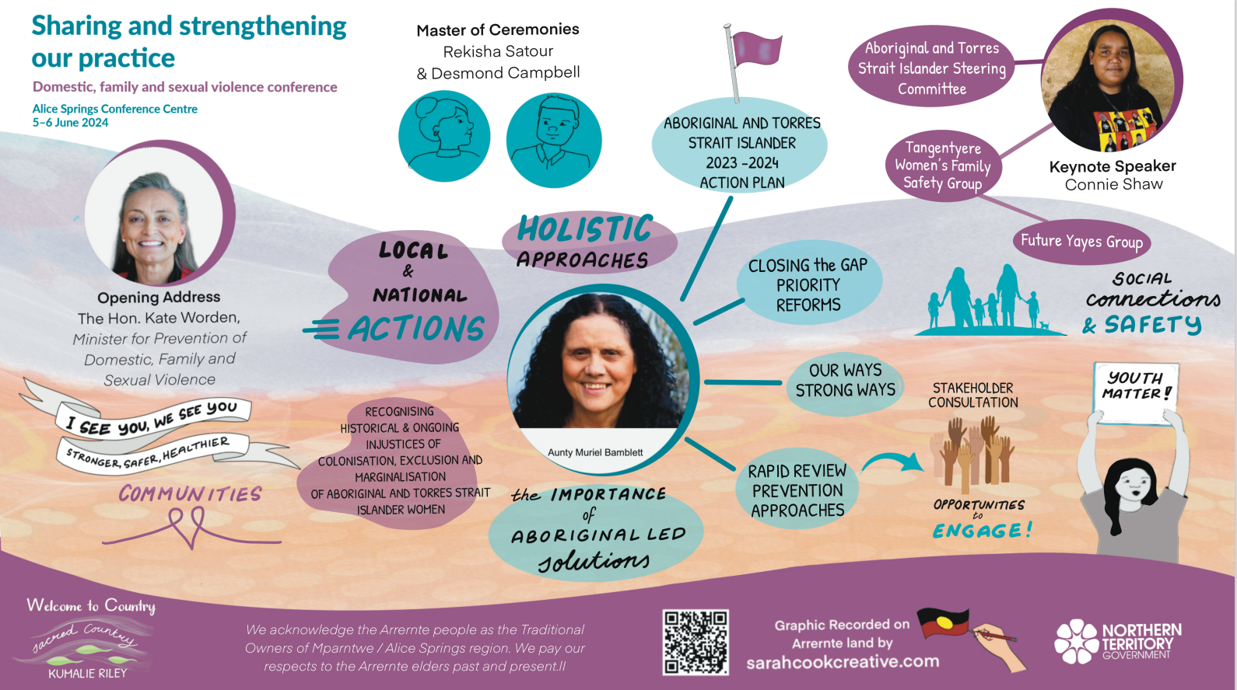
Session Graphic Illustrations

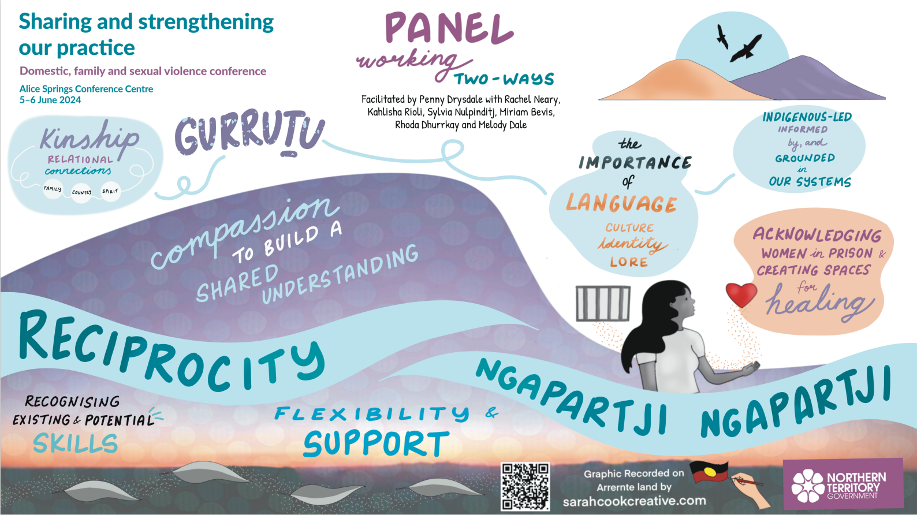
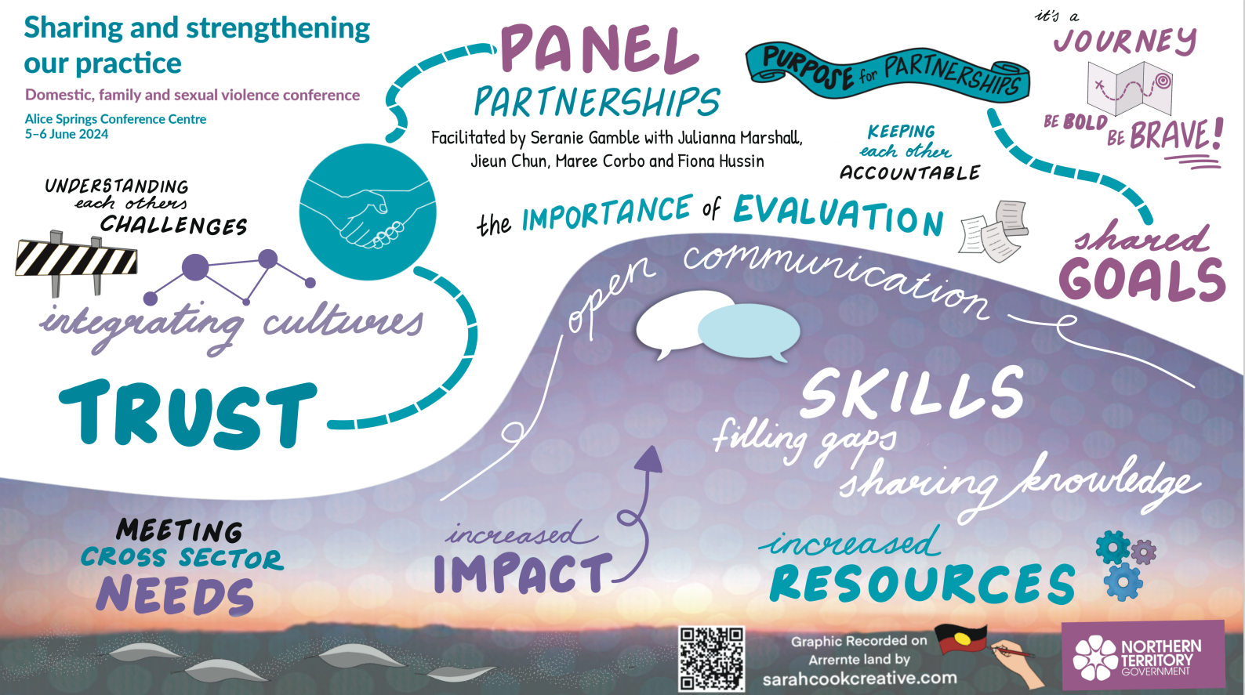
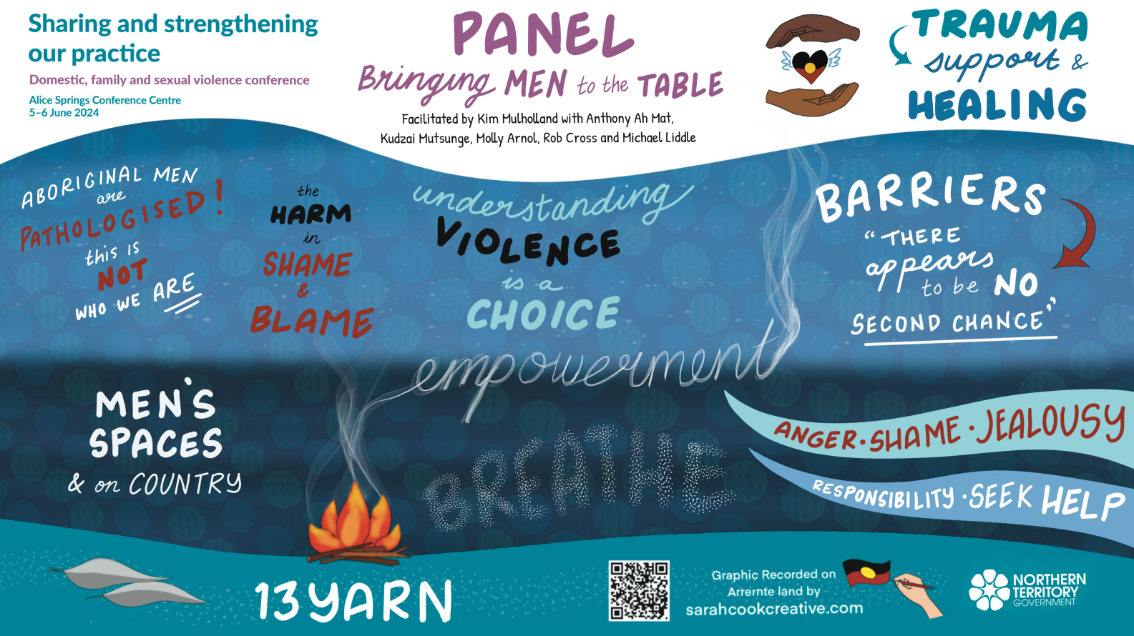
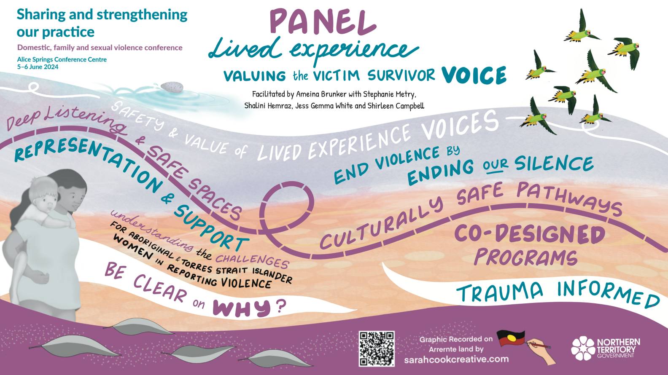
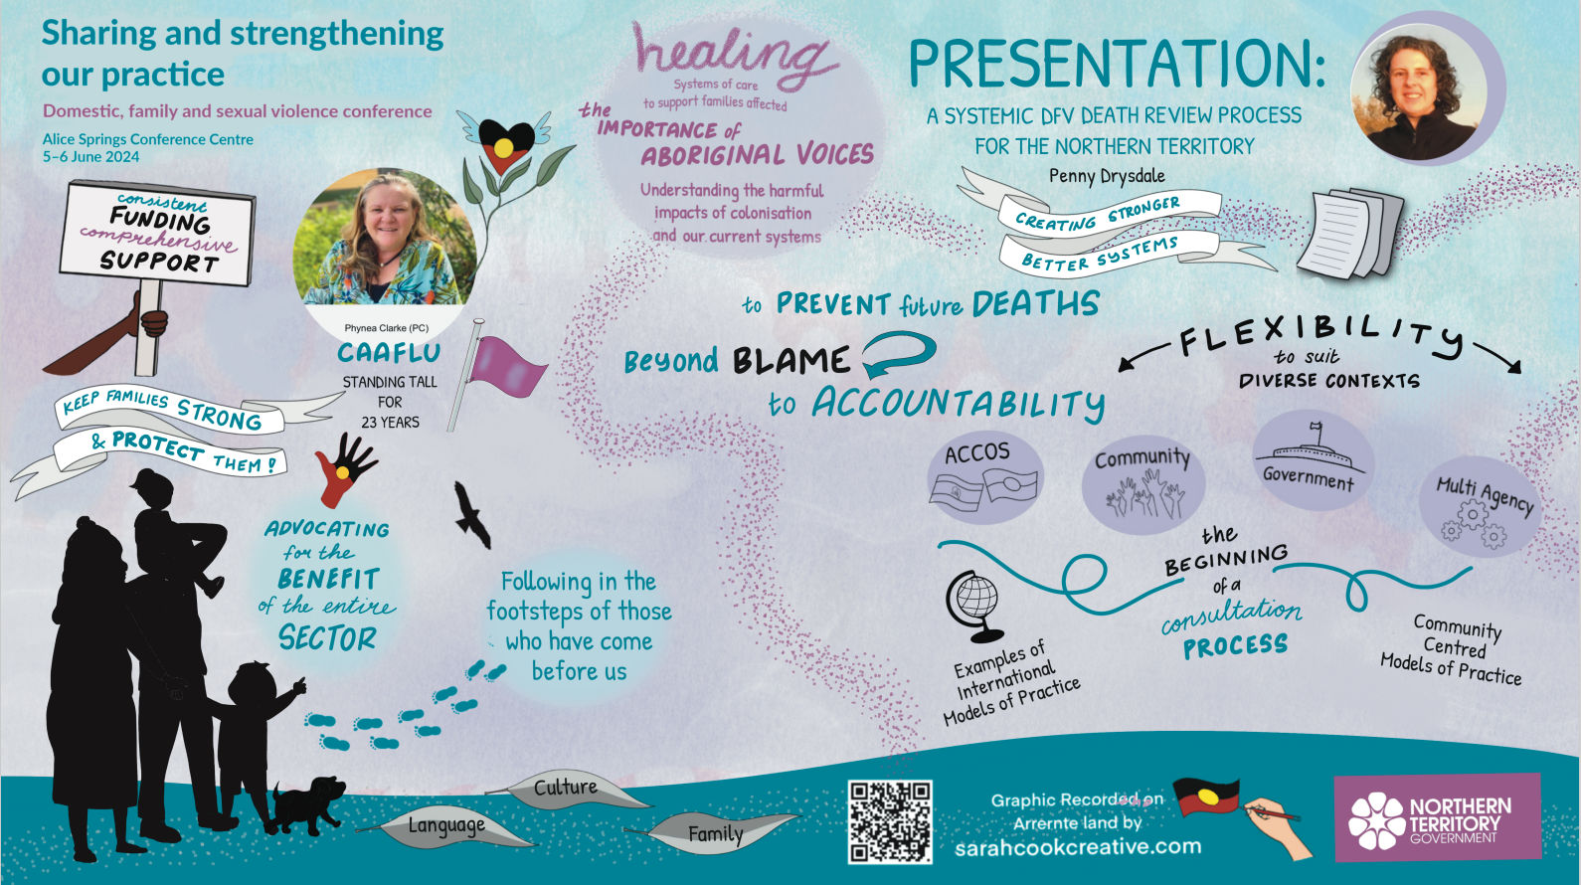
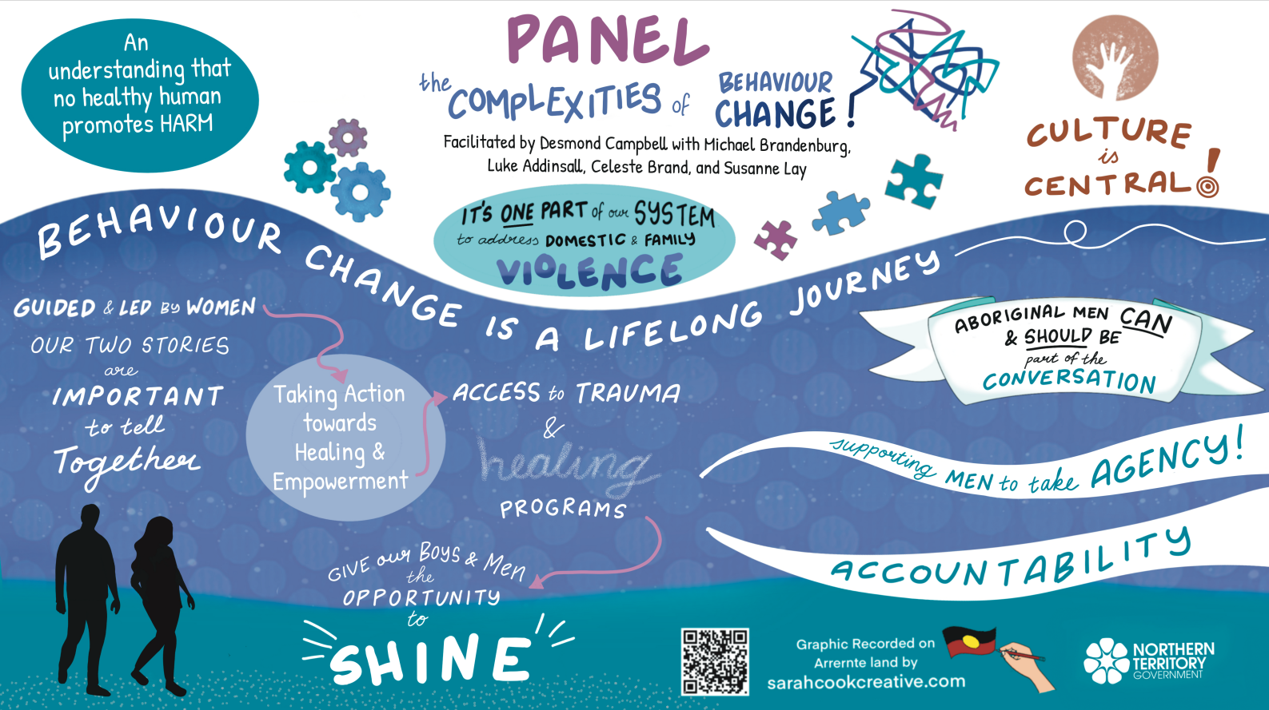
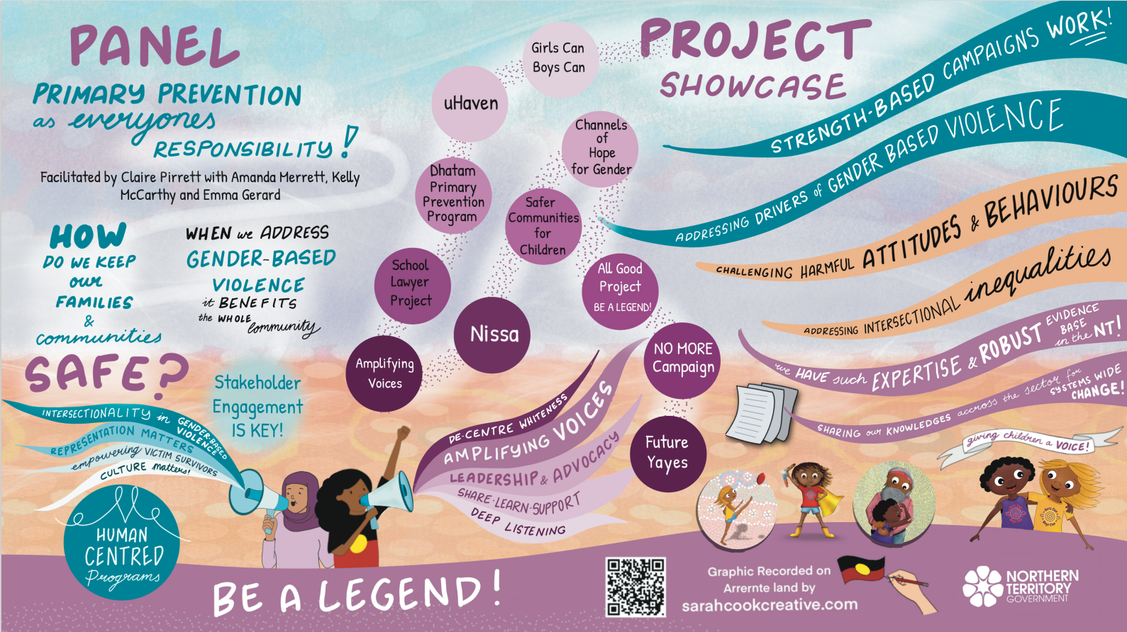

There is incomplete data for all delegates as a result of late registrations and on the day walk-ins. The numbers represented in this report are from those who registered with the conference organiser and attended.
Figures are rounded to the nearest thousand.

