NT DFSV Primary Prevention Community of Practice Workshop 10-11 June 2026

Overview
The NT Domestic, Family and Sexual Violence (DFSV) Primary Prevention Community of Practice (CoP) was established by the NT Government (NTG) in partnership with Our Watch. It is a key action of the DFSV Reduction Strategy 2025 - 2028 and the DFSV Workforce and Sector Development Plan. Further details regarding the membership, purpose and function of the CoP can be found in the CoP Terms of Reference.
The Community of Practice members and guests met in person in Darwin for two days of workshops on 10 and 11 June 2026. There were 30 participants over the two days, including key Our Watch and NT Government stakeholder team members.
Workshop sessions were facilitated by Our Watch staff, Restorative Yarns, Darwin Community Legal Service, NT Aids and Hepatitis Council and YWCA, and presentations were delivered by Community of Practice members – Music NT and United Muslims NT, as well as the Office of DFSV from the Department of Children and Families (DCF). Participants were presented with a diversity of topics, demonstrating the breadth of primary prevention work and engaged in activities and discussion designed to facilitate peer connection.
The NT Department of Children and Families provided the funding for the event, including participant accommodation and travel as required, and Our Watch administered the financial arrangements.
This meeting summary was prepared by the Our Watch Senior Advisor, Primary Prevention (NT) as part of reporting to the NT Government under the partnership between the NTGovernment and Our Watch, which includes a deliverable relating to facilitating the CoP.

Attendance
Members were invited to nominate up to 2 colleagues per project to attend the workshop. There were 30 participants across the two days, 18 participants were CoP members from across 8 projects, including Relationships Australia (NT), who were guests of the CoP this year.
CoP Members:
Organisation | Project | Work location | Staff
Aboriginal Resource Development Services (ARDS) | Respectful Relationships Workshops and Resources for Yuta Yolngu | Darwin, East Arnhem Land | 3
Aboriginal Resource Development Services (ARDS) | Ḏälkum Yolŋu Gurruṯu (Strengthening Yolŋu Kinship) Project | Darwin, East Arnhem Land | 3
Catholic Care NT | No More | Darwin, across NT | 2
Katherine West Health Board | Strong Men Leading Change program | Katherine region | 1
NAPCAN | Safer Communities for Children | Darwin, across NT | 1
United Muslims NT (UMNT) | Nisaa | Darwin | 5
YWCA | Amplifying Voices – A leadership program for young women with lived experience | Darwin | 3
Relationships Australia NT | Healing our Children project | Darwin | 1

Workshop Overview
The workshop sessions covered a diversity of topics, providing participants with insights into the depth and breadth of primary prevention work. The 4 main sessions went for almost 2 hours each, providing enough time for presentations, interactive components and questions. Each afternoon there was a presentation from a CoP member primary prevention project.
Day 1:
- Saltwater Welcome to Country by Mary Williams.
- Welcome by Seranie Gamble (DCF) and Sanjugta Vas Dev (Our Watch)
- Introductions by Asha Bradley (Our Watch)
- Session 1: Decolonising Practice – Walking the Talk facilitated by Evie Rankmore and Toni Hawkins (Our Watch)
- Session 2: Sacred Embers and Collective Care (Restorative Yarns)
- Community Spotlight, Danielle Andrews (Music NT)

Day 2:
- Acknowledgement of Country and Introductions by Asha Bradley (Our Watch)
- Update on DFSV work within the DFSV Prevention Division by Sarah Grace (DCF)
- Session 1: Preventing Violence against LGBTQIA+ people and communities (Our Watch, NT AHC, and DCLS)
- Session 2: Valuing Lived Experience, Carlee Heisee and two advocates from the Amplifying Voices Advocacy Program (YWCA).
- Community Spotlight, Maryam Razi (United Muslims NT)

Workshop Insights
Although the workshop was not organised around a single overarching theme, a consistent thread across the two days was the value of hearing from diverse voices and perspectives. The program intentionally created space for participants to explore different approaches to primary prevention, drawing on lived expertise, community knowledge and professional practice. Collectively, the sessions reinforced the importance of intersectional, culturally responsive and community-led approaches to preventing domestic, family and sexual violence.
Session 1: Decolonising Practice – Walking the Talk (Our Watch)
Purpose
This session explored Our Watch's journey to embed the principles of Changing the Picture into organisational practice, demonstrating the importance of “walking the talk” as a violence prevention organisation.
Key insights
- Decolonising practice starts from the inside and requires ongoing organisational reflection and commitment.
- Participants discussed how these approaches could inform the implementation of primary prevention initiatives across government.
- There was strong interest in culturally appropriate communications, including media reporting on First Nations peoples and examples of Aboriginal-led communications and advocacy initiatives across the Northern Territory.
Key learning for primary prevention practice: all institutions shape social conditions, and these can either be positive or negative. For organisations like Our Watch that are trying to transform structures and institutions towards greater equality for all people, it is important that they are able to lead by example, showing that systemic change is not only possible but also comes with demonstrable benefits to employees and workplaces.

Session 2: Sacred Embers and Collective Care (Restorative Yarns)
Purpose
Participants explore narrative tools, including yarning circles, river ecology and oracle cards, to support conversations grounded in Country, lived experience and community context. The tools were designed by First Nations practitioners, with the oracle cards developed through a sexual violence prevention project focused particularly on Aboriginal and Torres Strait Islander LGBTQIA+SB people.
This session invites reflection to explore the many identities, stories and lived experiences we all carry, and how they are shaped by broader systems of power, inequality and oppression. This reflective practice is important to primary prevention, supporting practitioners to look beyond individual experiences and behaviours to understand how intersecting systems and social conditions shape experiences of violence and the underlying drivers of violence against women and children.
Key insights
- The session highlighted the importance of understanding the historical, social and structural factors that continue to shape First Nations peoples’ experiences, as a foundation for culturally responsive, safe and trauma-informed prevention practice.
- Narrative approaches can surface stories of trauma and disadvantage alongside survival, strength and resilience, bringing community knowledge and lived experience into prevention work.
Participants reflected on intersectionality and how different aspects of identity and experience can intersect with systems of power and oppression, while also being sources of strength, connection and resilience.
Key learning for primary prevention practice: Effective/culturally safe primary prevention practice requires an intersectional and context-responsive approach that considers how histories, identities and systems of power shape both experiences of violence as well as empowerment and resilience.
Session 3: Preventing Violence against LGBTQIA+ People and Communities (Our Watch, NT AHC and Darwin Community Legal Service)
Purpose
This session introduced emerging national work to prevent violence against LGBTQIA+ communities and explored how inclusive and intersectional approaches strengthen primary prevention.
Key insights
- Participants examined evidence relating to violence experienced by LGBTQIA+ communities alongside findings from Northern Territory consultations.
- The Private Lives 3 national survey to illustrate the prevalence of violence experienced by LGBTQIA+ communities. The survey found that 60.7% of respondents had experienced intimate partner violence, 64.9% had experienced family violence, and 40.8% of all respondents had experienced LGBTQIA+-related abuse from a family member.
- The session reinforced that work to advance gender equality, and LGBTQIA+ equality are closely connected because the drivers of violence against both groups have significant overlap.
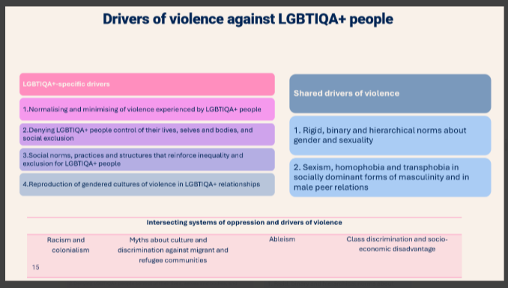
Figure 1: Drivers of Violence against LGBTIQA+ people and shared drivers of violence against women, Our Watch and Rainbow Health Australia, Changing with Pride (forthcoming)
- Key principles included meaningful community engagement, community ownership, values-based messaging, and intersectional practice.
- Anonymity, privacy, stigma, and a lack of specialised services is a significant barrier for LGBTQIA+ people seeking help and services, particularly in the NT.
Key learning for primary prevention practice: LGBTQIA+ inclusion should be embedded within primary prevention work. Homophobia, transphobia, heteronormativity and rigid gender norms are interconnected, aiming to reinforce ideas of appropriate masculinity, feminity and relationships, underpinning violence against both women and LGBTQIA+ people.

Session 4: Valuing Lived Expertise (YWCA)
Purpose
YWCA presented its Amplifying Voices program, with lived expertise advocates in that program sharing their experiences of turning their experiences into expertise that can ultimately strengthen DFSV prevention and response.
Key insights
- Participants gained insights into the benefits of incorporating lived expertise into ways of working, including shared decision-making and adopting a flexible pace that accommodates the needs of survivor advocates, as well as into organisational practice, such as the development of tools and advocacy approaches.

- The session highlighted practical, trauma-informed considerations for embedding lived expertise, including flexibility around time commitments, clear expectations about participation, regular check-ins and positioning survivors advocates as leaders and drivers of the work, rather than simply participants.

- Discussion explored the value of lived expertise in grounding complex prevention concepts in personal stories and experiences, helping to connect structural and theoretical understandings of violence with how they are experienced in people’s lives.

Key learning for primary prevention practice: Lived expertise is important to shape primary prevention evidence, understanding, priorities, programs and advocacy. But meaningful engagement based upon genuine partnership that is not tokenistic or exploitative requires listening, consideration and adjustment of engagement processes.

Community Spotlight: All Good Project – Music NT
Purpose
Music NT shared its All Good Project, demonstrating how primary prevention can be embedded within the live music industry to create safer and more inclusive environments.
Key insights
- The All Good Project is a practical example of prevention in non-traditional settings, including festivals, venues, and the broader music industry. Works in partnership with authorities, governments and licensees.
- The presentation demonstrated how active bystander training for staff contributes to safer environments for everyone.
- Discussion revealed significant interest and demonstrated the various settings for primary prevention.
Community Spotlight: United Muslims NT – NISSA
Purpose
United Muslims NT presented its NISSA project, a primary prevention initiative delivered through faith-based, family-centred and community-led approaches.
Key insights
- NISSA uses Islamic teachings to reinforce the idea that violence is inconsistent with faith and reinforces the values of respect, equality and compassion within Islamic teachings.
- NISSA uses a family-based approach and holds “Sisterhood” and “Brotherhood” circles (“Ilm” Circles/Knowledge Circles) to hold these discussions and deliver these messages around non-violence and respect. Families are invited, food is provided and care is available for the younger children, whilst men and women are divided into separate “circles”.

- Partnership with Saving Face – a national primary prevention initiative developed by Muslim Women Australia.

- Discussion highlighted how creating trusted, culturally safe spaces supports learning, dialogue and community ownership.
Department of Children and Families Update
Purpose
The Domestic, Family and Sexual Violence Prevention Division within the Department of Children and Families provided an update on current priorities, governance arrangements and implementation of the NT DFSV Reduction Strategy.
Key insights
- Participants received an overview of current government priorities, including primary prevention initiatives, grants, regional coordination and monitoring and evaluation e.g. strategic policy, grants, regional coordination based across 5 regions, establishing a DV hub in Darwin, RAMF etc.
- Participants also considered how government monitoring and evaluation approaches can better recognise Aboriginal-led theories of change and locally determined evaluation approaches.
Community Reflection: ARDS Peacemaking Approach
ARDS shared reflections on its developing Peacemaking Approach using Yolngu metaphor. Participants discussed Aboriginal-led approaches to healing, collective responsibility and the importance of moving at the pace of community. The discussion reinforced many of the themes explored throughout the workshop, including community leadership, cultural strength, relational approaches, connection to nature, and the importance of walking alongside communities in prevention work.

Participant Feedback
The workshop evaluation was distributed to the 18 Community of Practice members who attended the workshop, with 9 participants completing the survey (50% response rate).
Overall satisfaction
Feedback indicated a highly positive participant experience.
- 100% of respondents reported being very satisfied with the workshop.
- Participants agreed that the workshop:
  - was relevant to their work
  - supported their prevention practice and professional learning
  - provided opportunities to learn from others
  - was well organised and facilitated
  - would be recommended to others working in primary prevention.
What participants gained
Across the six workshop sessions, participants most commonly reported that the sessions:
- introduced new ideas and perspectives
- reinforced or deepened their existing knowledge
- provided practical ideas and resources they could apply in their work
- increased their understanding of different approaches to primary prevention
- were directly relevant to their work.

The most commonly reported outcomes for each session are summarised below.
Session | Most commonly reported outcomes
Decolonising Practice | Reinforced or deepened existing knowledge; introduced new ideas and perspectives
Sacred Embers and Collective Care | Introduced new ideas and perspectives; provided practical ideas and resources
Preventing Violence against LGBTQIA+ People and Communities | Increased understanding of different approaches to primary prevention; provided practical ideas and resources/reinforced existing knowledge
Valuing Lived Experience | Provided practical ideas and resources/reinforced existing knowledge; directly relevant to participants' work
Community Spotlight – Music NT | Introduced new ideas and perspectives/increased understanding of different approaches to primary prevention; reinforced existing knowledge
Community Spotlight – United Muslims NT | Reinforced existing knowledge; increased understanding of different approaches to primary prevention

Key themes from participant feedback
Three key themes emerged from participants' qualitative feedback.
Learning from diverse perspectives
Participants valued hearing from organisations working in different communities and contexts. Many described the breadth of perspectives and approaches to primary prevention as inspiring, affirming and directly relevant to their own work.

Connection and networking
The opportunity to connect with practitioners from across the Northern Territory was consistently identified as a key strength of the workshop. Participants appreciated the chance to build relationships, exchange ideas and strengthen connections within, and beyond, the Territory's primary prevention sector.
Practical learning and reflection
Participants described taking away practical tools, new ways of thinking and approaches that they could apply in their own work. Themes included the importance of deep listening, community-led practice, valuing lived expertise, and broadening perspectives through learning from primary prevention work from different perspectives (e.g. LGBTQIA+/faith-based) and in different settings (e.g. Music venues).
Selected participant reflections
"The need to slow down and listen deeply and richly to each other – not just with our ears and minds, but with our hearts."
"Greater connection to others doing primary prevention work – it's a small but important sector."
"The breadth of people and intersection of ideas was powerful."
"I loved the United Muslims NT spotlight – this work was from a community I am not involved in or work with, and it was very illuminating and inspiring."

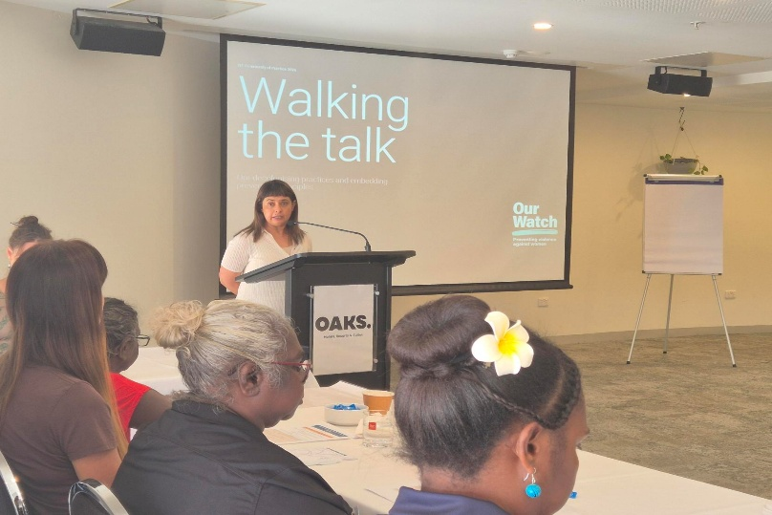

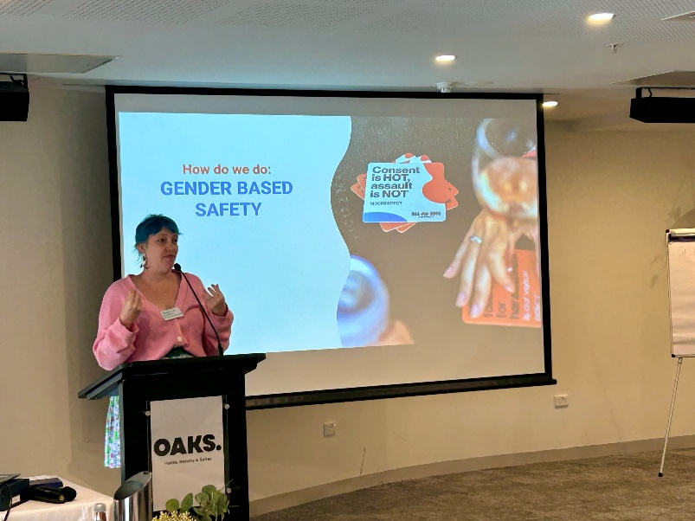
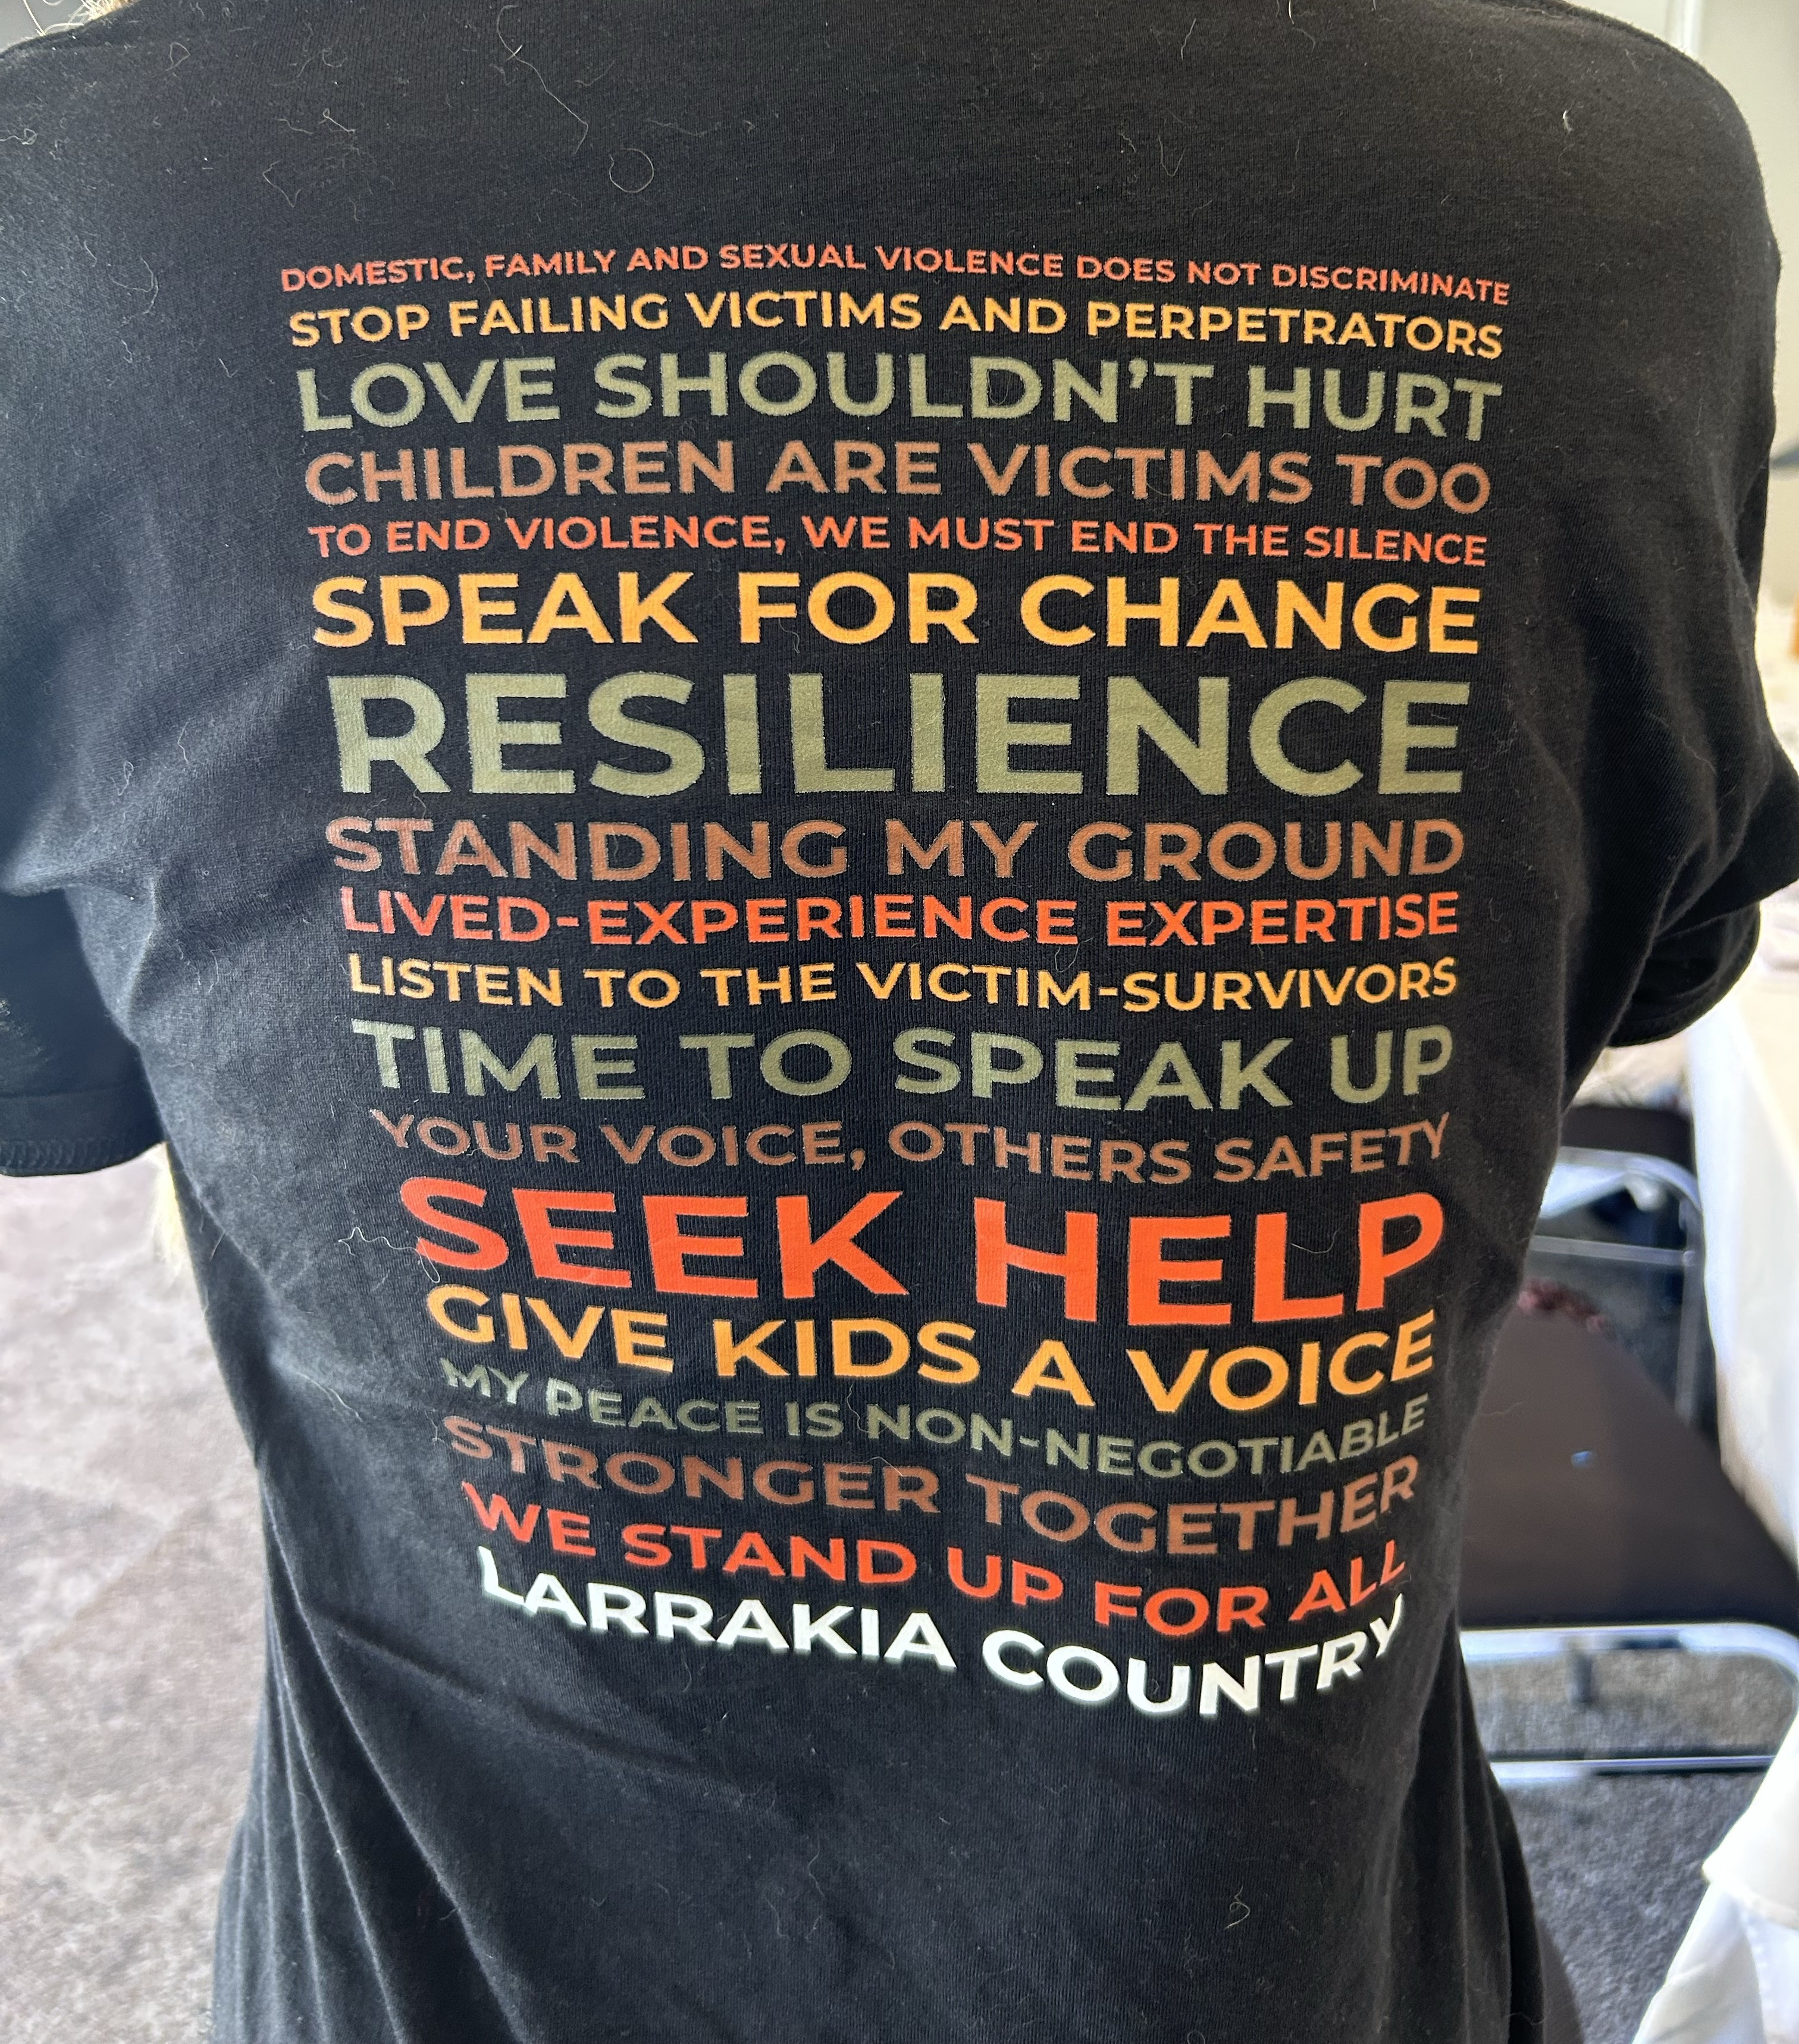
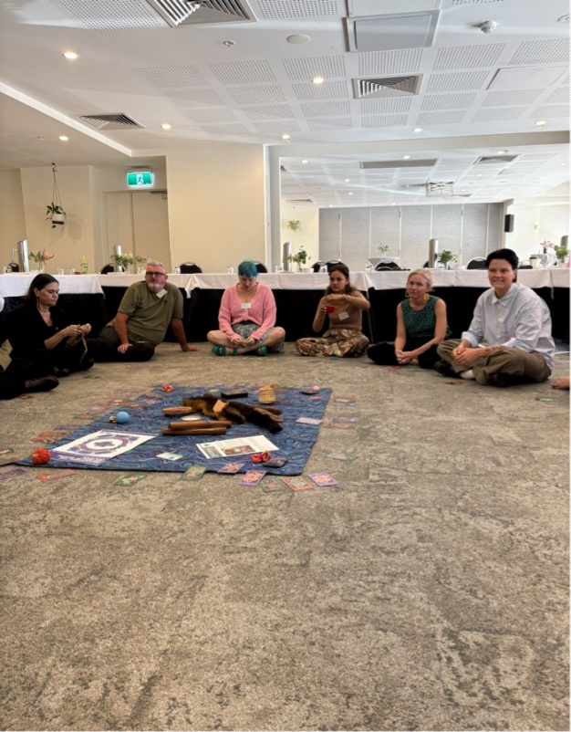

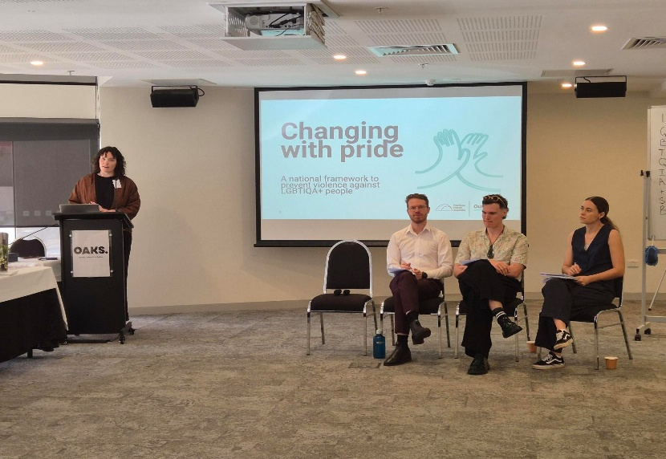

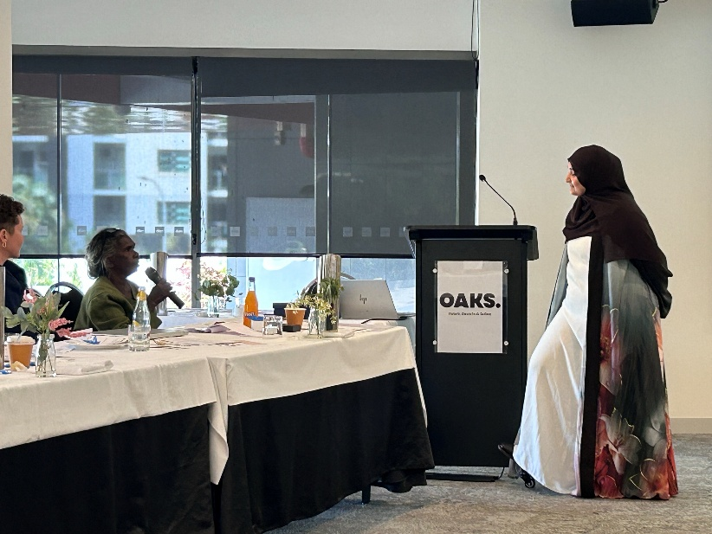

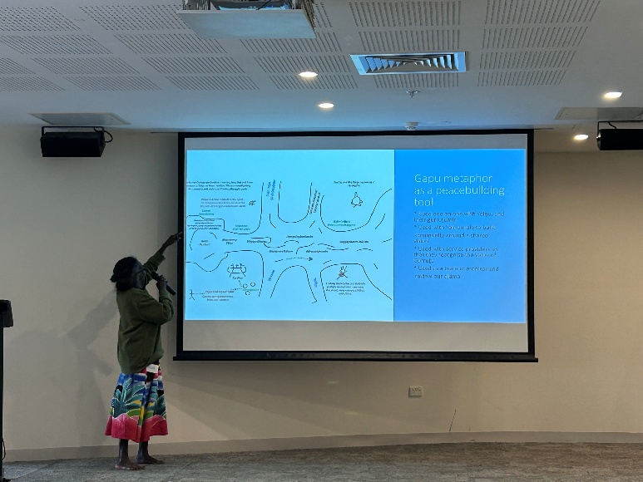

Figure 2 This image depicts Rhoda Goluŋ Dhurrkay presenting a Yolŋu-led project strategy design based on the gapu (water) metaphor for the Dälkum Yolŋu Gurruṯu project (strengthening Yolŋu kinship). The image, language and associated metaphor represent Yolŋu Intellectual Property and must not be reproduced, distributed, adapted, or used without prior permission. For enquiries regarding use of this material, please contact ARDS Aboriginal Corporation.

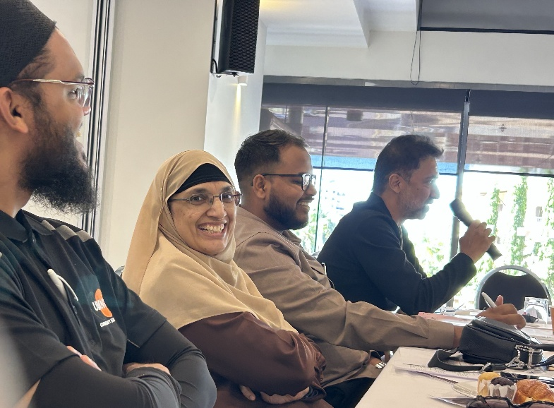

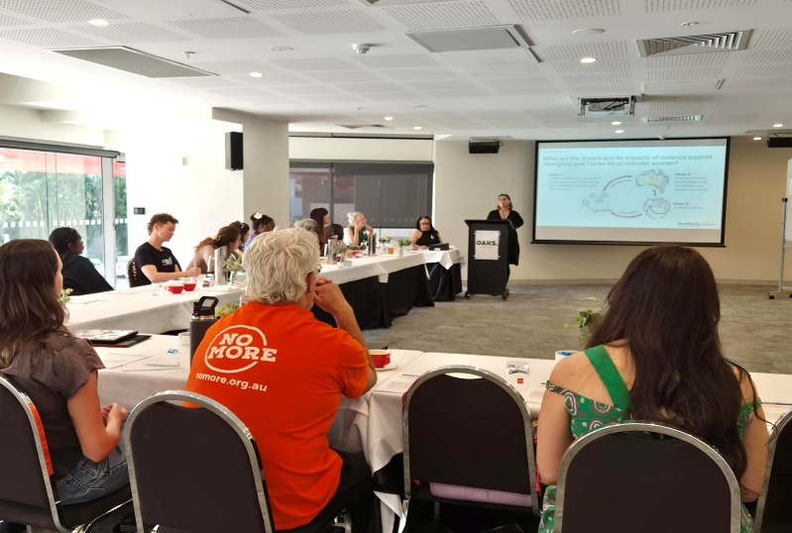

These TOR are due to be updated for the next round of primary prevention grants project beginning 1 July 2026. The most significant difference to note is that since these TORs were developed an Aboriginal-led Primary Prevention Grants program that began in July 2025 with the following 3 projects: 1) Katherine West Health Board – Strong Men Leading Change; 2) Jawoyn Association Aboriginal Corporation – Ngalmuka Healing – Our Way; 3) Aboriginal Resource and Development Services - Dalkum Yolgnu Gurrutu (Strengthening Yolgnu Kinship) Project.
The Healing our Children project, run by Relationships Australia NT, is not a grantee of the NTG’s primary prevention grants project, however they have been a guest between February to June 2026 in the primary prevention CoP.
FACE stands for Saving Faith and Cultural Empowerment.

