Welcome to our home

My/Our Names Are:

[Insert name/s] *include a picture of yourself or you’re your home below*

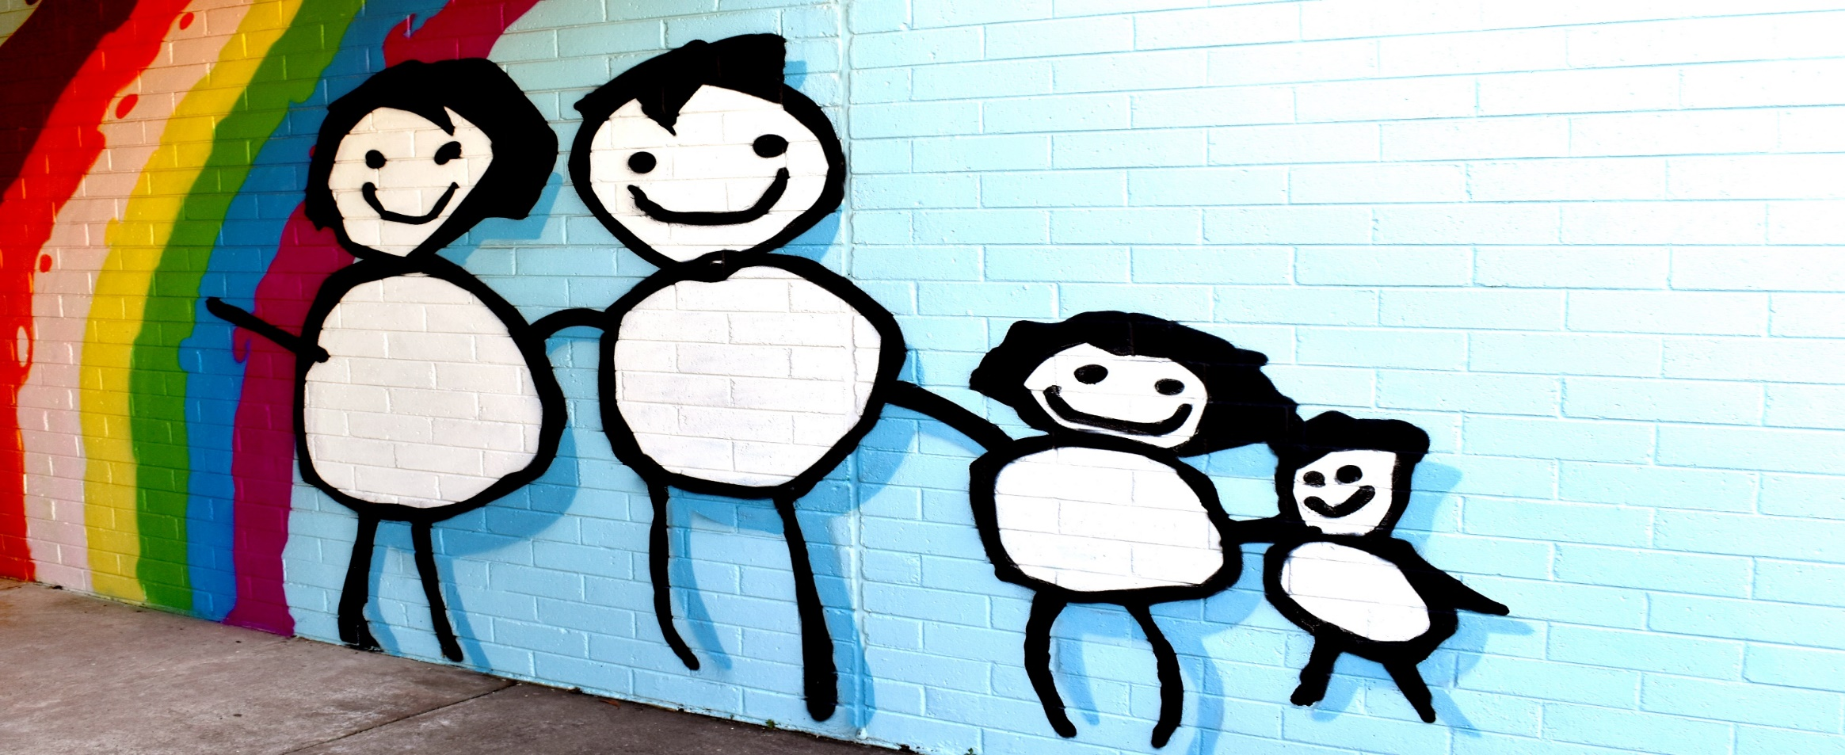



About us

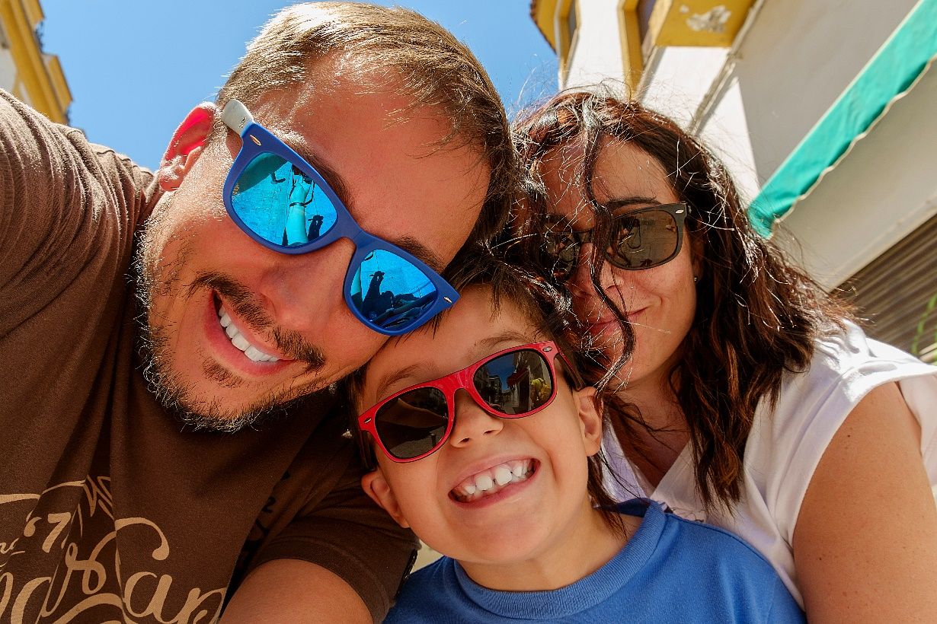

In this box, include a short blurb about each of the caregivers: name, occupation, interests, how long they have been caregivers for (if applicable).

Culture: What is the culture of the home? And how does this play a role in the way the family lives?

Include the caregiver’s feelings about the new placement. “We can’t wait to meet you and are happy to have you in our family.”

Include a picture of yourself in the box to the right.

Who lives with us

Name of the people in the box to the left

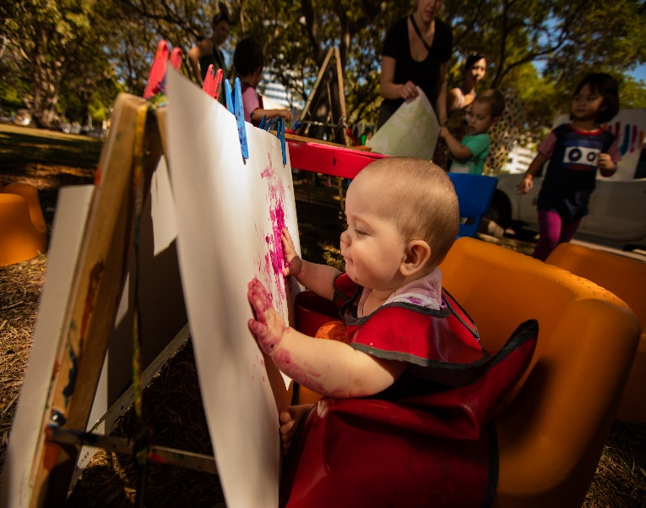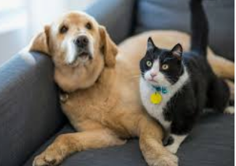

**SAMPLE IMAGE**

**right click to replace**

**SAMPLE IMAGE**

**right click to replace**

Name of the people or pets the box to the right

For each other person living in the home (besides the caregivers), include:

* First name
* Age & gender
* their relationship to the caregiver
* Their interests, sports, hobbies (optional)

Include information about your pets.

In the boxes to the right, insert a photo of each person living in the home.

Where we live

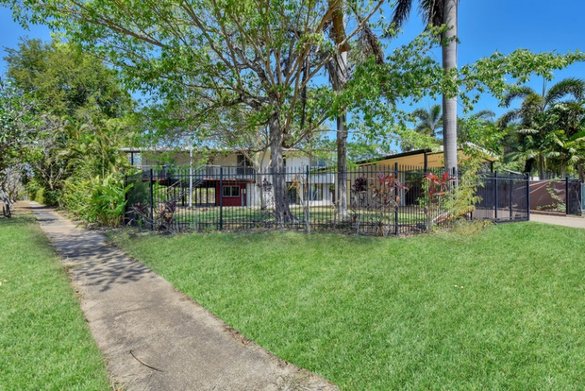

In this box describe the area (urban/rural/near the sea/schools etc) you live.

Describe your house and garden.

In the boxes to your right include pictures of your house, neighbourhood, and/or yard.

Information on the neighbourhood i.e. there is a park across the road with a slide, pool, library, river, etc)

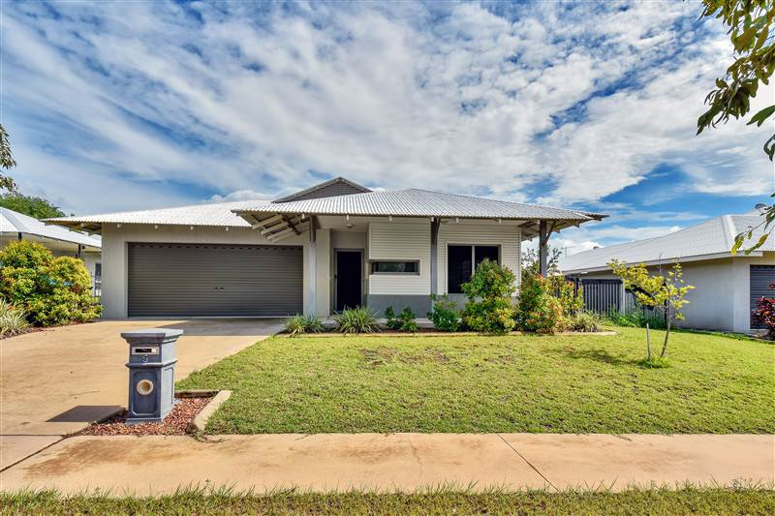

**SAMPLE IMAGE**

**right click to replace**

**SAMPLE IMAGE**

**right click to replace**

Our family life

HOW WE DO THINGS

For teens, include curfews, and household expectations.

E.g. we get our chores finished before any screen time is allowed.

In my/our home we like children/young people to ….. e.g. tell us/me if they are worried about something; always let us know where they are going etc.)

FAMILY ACTIVITIES/ROUTINES

What do you do on a typical day or weekend?

What does your family do together for fun?

What daily routines does your family have e.g. getting ready in the morning, we leave a light on in the hallway each night, mealtimes etc.

Things to do for fun

Include in this section what the family likes to do for fun, or what activities there are to do in the house or in the neighbourhood.

In the below boxes, include photos of the fun things mentioned, e.g. nearby park, toys, garden or any other relevant photos.

